A Moment of Conscious Experience is Very Informative

Alon Loeffler

Word Count: 11,982

A paper submitted in partial fulfillment of the requirements of the degree of

*Bachelor of Science (Honours)*

*School of Psychological Sciences,*

*Monash University,*

*October 2017*

Table of Contents

Abstractv

Statement of Contributionvi

CHAPTER 1: INTRODUCTION2

Limits of Reports from Brief Exposure to a Visual Scene2

Is Richness Illusory?4

Ensemble statistics: A sparseness solution to information processing5

Phenomenal and access consciousness7

Experimental support for phenomenal consciousness8

High-capacity information processing persists after visual masking11

How Quickly Can We Process Information?12

Bandwidth of Sensory Input vs Bandwidth of Consciousness13

Introspection as a Tool for Measuring Visual Information17

Methodological Limitations of Previous Paradigms18

Overcoming Methodological Limitations: Psychophysics19

The Present Study 22

CHAPTER 2: METHODS AND RESULTS 24

General Results 24

Participants24

Materials24

Stimuli25

Images25

Image Descriptions26

Procedure28

Data Analysis31

Signal detection theory31

Area under the curve (AUC): A measure of objective accuracy34

Using objective accuracy to define bits/sec34

Differences between experiments35

Experiment 1: Determining target SOA 36

Methods 36

Data Analysis 36

Results 37

Quantifying conscious information processing37

Discussion38

Measuring maximum performance on the task38

Selecting a target SOA for experiments 2 and 340

Experiment 2: Testing multiple questions per image40

Methods 40

Data Analysis 41

Results 42

Conscious information processing: bits/question and bits/sec 43

Experiment 3: Testing the limits of reporting44

Methods 44

Data Analysis 44

Results 45

Conscious information processing 45

General Results 46

Performance Trend across 1, 10 and 20 questions at 133ms SOA47

Objective accuracy and confidence across experiments47

Information processing per-second48

Bits/sec efficiency48

Comparing present and absent judgements50

Can people report on both present and absent words for 20 questions, without decay of accuracy?53

CHAPTER 3: DISCUSSION AND CONCLUSION56

General Discussion56

How well did participants perform on the task?56

Objective accuracy56

Objective accuracy does not decay after 20 questions57

Measuring conscious information58

Efficiency58

Do Absent Judgements Constitute Information?58

Are Absent Aspects More Informative Than Present Aspects?59

Limitations60

Significance and Implications 61

Significance 61

Support for phenomenal consciousness63

Implications 63

Future Directions/Research65

Conclusion 66

Author Notes 67

CHAPTER 4: REFERENCES 68

Appendices & Supplementary MaterialsSee Attachments

Abstract

Our visual experience of the world seems highly rich. However, previous studies show that the amount of items people can report on in any given scene is severely limited (up to a maximum of 40 bits-per-second). This has led to a dominant view in the literature that richness of consciousness is illusory. Nonetheless, these studies only considered whether people can report on the presence of items, among limited and predetermined options. Here we used a huge repertoire of natural scene descriptions and assessed if subjects can report not only what was present but also what was absent. With this novel method, we found that people can consciously report 100 bits of information per-second from a natural scene with high accuracy. Furthermore, people are more accurate when reporting on absent aspects of a scene than present aspects. Our estimate serves as a lower-bound for the amount of information people can consciously process. We concluded that people consciously process much more information than previously estimated in the literature.

Statement of Contribution

The present project was produced by the author, in collaboration with A/Prof. Naotsugu Tsuchiya and A/Prof. Jeroen van Boxtel of the Tsuchiya Laboratory, Monash Neuroscience of Consciousness (MONOC), Monash University. The author determined key elements of the study design and choice of measures used, with guidance from both collaborators. These included cleaning image descriptions using MATLAB, the use of confidence ratings, and the calculation of information processing. The author coded all of the psychophysics tasks himself, which took approximately 400 hours over twelve weeks, with support from Mr. Julian Matthews, a PhD student from the Tsuchiya lab, as well as the two main collaborators. All images and descriptions were collected and provided by Shinji Nishimoto and Satoshi Nishida in Japan, and collated, translated and cleaned by the author.

The author formulated the aim and hypotheses of this study, and performed the participant recruitment and data collection, which included face-to-face testing sessions of 37 participants (seven of which were discarded due to code issues). Testing for the present study took approximately 1-1.30 hours per participant; the author completed a total of approximately 60 hours of data collection over four weeks.

The author wrote MATLAB scripts used to calculate values for information and all other statistical analyses. The scripts to calculate objective accuracy were provided by Mr. Julian Matthews. The author used MATLAB to complete statistical analyses and graphical representation of data. The author prepared the final paper, and both collaborators critiqued drafts. The written material presented in this document is the author’s own work, and feedback has been obtained once from each collaborator.

Signed: 

**CHAPTER 1: INTRODUCTION**

Our visual experience of the world seems highly rich; from the moment we wake up, we experience a vast, extremely detailed visual world, extended to the very edges of our periphery (Dennett, 1991). We can infer that people experience a dense and immensely detailed visual field through their verbal reports (Fei-Fei, Iyer, Koch & Perona, 2007; Haun, Tononi, Koch & Tsuchiya, 2017). Nonetheless, there seems to be a discrepancy between how much detail we believe we see (our subjective experience of the world) and the amount we can report on (what we can tell others about our experience of the world; Bronfman, Brezis, Jacobson, & Usher, 2014; Haun et al., 2017).

**Limits of Reports from Brief Exposure to a Visual Scene**

Introspectively, consciousness seems rich in content, yet from the third-person perspective of neuroscientists, consciousness is “rather miserable” (Lamme, 2010; see Appendix A for glossary of key terms).When controlled experiments attempt to quantify visual experience, participants only report a limited number of items (Cohen, Dennett & Kanwisher, 2016). For example, Sperling (1960) showed participants 12 letters (see Figure 1a) for a duration of 50ms, asking them to recall as many as possible. The maximum number participants could recall from the whole letter array was 4-5. Similar tasks, including change-detection (e.g. Rensink, 2002), visual search (e.g. Rosenholtz, 2011), and inattentional blindness (e.g. Horrey & Wickens, 2006) paradigms, have capped the number of reportable items in any given scene at five (Clarke & Macke, 2014; Franconeri, Alvarez & Enns, 2007). This number can be increased to 7±2 when employing techniques such as chunking (Miller, 1956). Nonetheless, a limited capacity of recollection seems to contradict our experience of the world as highly detailed, possibly hinting that these measured limits are imposed on cognitive mechanisms[1]* such as working memory[2]*, rather than on conscious perception as a whole.

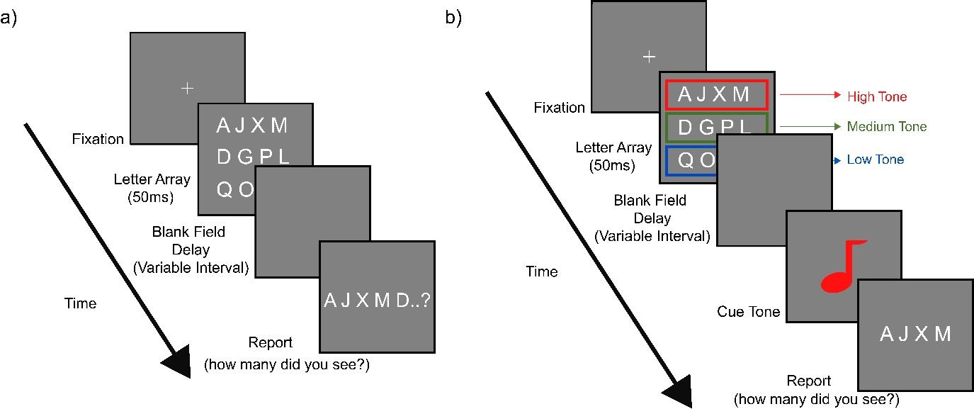

*Figure 1.* Example of a single trial in the Sperling (1960) Task. (a) *Whole-report paradigm*: Participants were asked to report as many letters as they can recall from the 12 letter array after its disappearance. They could only recall 4-5 letters out of the 12. (b) *Partial-report paradigm*: Participants were asked to recall either the top, middle or bottom line of letters, corresponding to a high, medium or low tone. After briefly seeing the array (50ms), they were shown a blank screen delay, for a variable interval (50-500ms). Participants were then played a cue tone, and asked to report which letters they saw from the corresponding row, in order. The tone was randomly sounded after the disappearance of the letters. When the delay was less than 250m, participants were accurately able to recall all of the letters in the prompted row, regardless of which tone was sounded, even though they did not have prior knowledge of which tone would be sounded.

**Is Richness Illusory?**

Since the number of items we remember is limited, these findings seem to imply that our real experience of the world is not as rich as we perceive. Many researchers argue that consciousness is intrinsically linked to cognitive mechanisms such as attention and working-memory, and information[3]* is not consciously perceived until it is accessed by these higher-order systems (Dehaene, 2014; Koudier et al., 2010; Miller & Buschman, 2015). They are often referred to as advocates of sparseness. For many sparseness advocates, visual experience consists mainly of the gist of a scene[4]*, as well as few objects that can be grasped by such cognitive mechanisms (Bronfman, et al., 2014). Norretranders (1998) summarises this idea by claiming that from instant to instant, consciousness can switch from one object to another; we do not perceive it as limited in its capacity. However, at any given moment, we are not conscious of much at all; there are limits to the flow of what goes through our consciousness at each moment, even though the next moment might produce something vastly different.

Advocates of sparseness argue that working memory is the main cognitive mechanism responsible for recalling information in previous studies (Luck & Vogel, 1997; Miller, 1956). Sometimes referred to as visual short-term memory, working memory contains information that is durable, resistant to perceptual interferences (such as masking), and accessible for report (Bronfman, et al., 2014). It has a severely limited capacity, yet demonstrably represents categorical and semantic information (Awh, Vogel & Oh., 2006; Fougnie, 2008).

In contrast, findings from Sperling’s (1960) secondary paradigm, called partial-report, indicate existence of a high-capacity memory that lasts around 250ms (Dick, 1974; Haber, 1971; Haber & Hershenson, 1973). Figure 1b outlines the altered procedure participants were instructed to follow in partial-report paradigm. When prompted to recall one row of four letters from amongst three rows, each corresponding to a high, medium or low tone, respectively, participants were accurately able to recall all letters in the prompted row. When the delay between presentation of 12 letter stimuli and sounding of the tone exceeded 300-500ms, participants’ ability to recall all letters in the corresponding row diminished significantly. This has led researchers such as Haber (1971) and Sperling (1960) to infer a high-capacity memory at up to approximately 250ms, which Neisser (1967) famously termed ‘iconic memory’. Recently, this duration has been shown to persist up to 1000ms (Clarke & Macke, 2015; Vandenbroucke, et al., 2014). There is conflicting evidence on whether iconic memory contains semantic or categorical information, however more recent studies suggest it contains greater amounts of information than previously thought (Keysers et al., 2007; Clarke & Macke, 2015). This question is revisited later in this thesis.

Limited recall demonstrated in controlled experiments, is thought by many advocates of both sparseness and richness to be influenced by limited capacity of cognitive mechanisms (such as attention) while transferring information from iconic memory to visual working memory[5]* (Bronfman, et al., 2014). Whether or not that information is available to consciousness prior to this transfer is a hotly debated issue.

**Ensemble statistics: A sparseness solution to information processing**

Sparseness theorists claim that incoming information remains in an unconscious state until attention is employed to amplify it into conscious awareness[6]* (Baars, 1989; Cohen & Dennett, 2011). According to this view, our impression of having a rich visual experience is caused by the nearly-immediate availability of rich representations when we shift our attention toward items previously unattended. This is likened to the incorrect impression that there is always light in the refrigerator because it is visible each time one opens the door (Cohen & Dennett, 2011; Kouider, de Gardelle, Sackur & Dupoux, 2010).

Cohen et al. (2016) offer one explanation for the discrepancy between a vastly detailed subjective experience and a severely limited recall capacity, arguing that richness is constructed statistically. They postulate our subjective experience of richness is constructed by the visual system through a process of summarization, representing groups of items as an ‘ensemble statistic[7]*’. These statistics are formed by averaging or “collapsing” across measurements of individual items to form a holistic description[8]* of groups of items (Cohen et al., 2016). For instance, items located outside the foveal receptive field[9]* (peripheral) and represented with poor resolution[10]* may be averaged across by the visual system, allowing it to obtain an accurate measure of the entire group (Alvarez, 2011). Our visual experience consists of high-level categories containing different types of information, such as brightness (Baur, 2009), size (Watamaniuk & Duchon, 1992), orientation (Dakin & Watt, 1997) and even gender or biological motion (Sweeny et al., 2013), that can be statistically summarised. Cohen and colleagues (2016) suggest this way of summarizing information from a scene can explain the ‘surprising’ side of sparseness – why we believe we see the world as highly rich. They use Figure 2 to demonstrate many aspects of a scene can be conveyed by a few basic ensemble statistics.

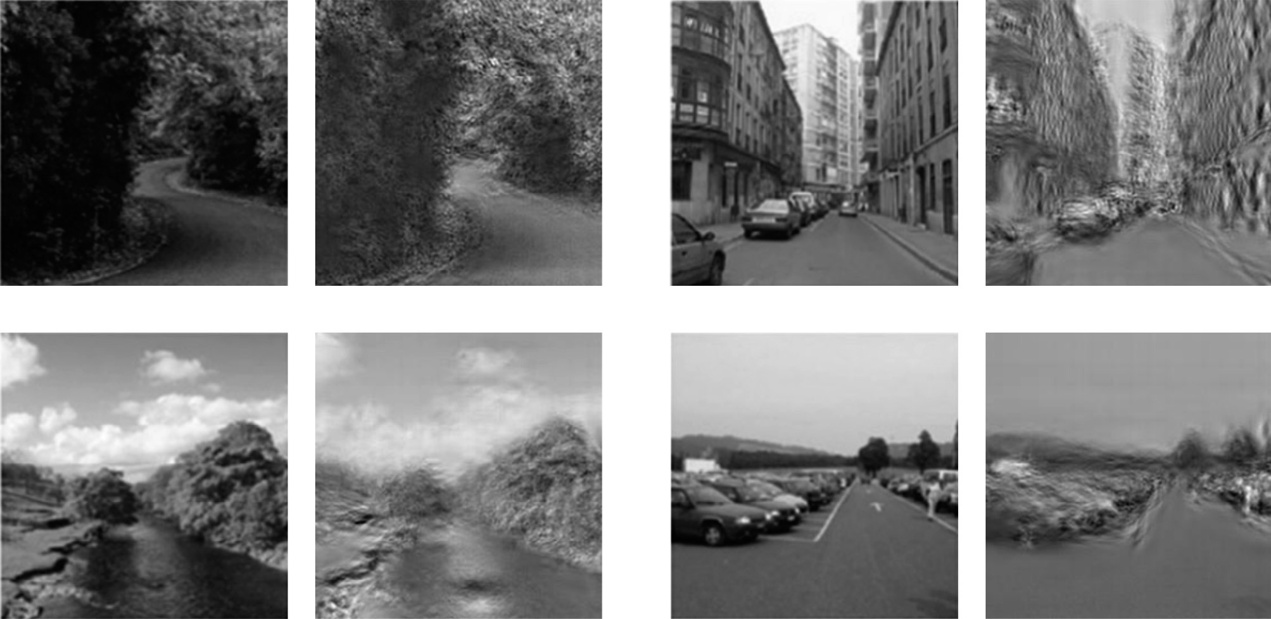

*Figure 2.*An example used by Cohen et al., (2016) to demonstrate ensemble statistics. Original image by Olivia and Torralba (2006). The scenes on the left reflect subjective experience of natural scenes. The scenes on the right are the same scenes with only certain global statistics of the image (coarse layout organization and levels of details) preserved.

**Phenomenal and access consciousness**

Block (1995; 2007; 2011; 2014), offers an alternative explanation for contradictions between subjective richness and measured sparseness. Mechanisms involved in conscious processes – such as reporting, remembering, or attending to items – fall under two distinct categories: ‘phenomenal’ and ‘access’ consciousness. Phenomenal consciousness corresponds to our subjective experience of the world, reflecting a rich and detailed experience. Contrastingly, access consciousness corresponds to information available to cognitive mechanisms such as attention and working memory, as well as verbal report.

Phenomenal consciousness is often equated to iconic memory (Block, 2014; Breitmeyer, 2015). That visual experience “overflows” the capacity of visual short-term memory forms the underlying basis for both concepts (Block, 2014; Lamme, 2010), although not without controversy (Clarke & Mack, 2015; Cohen & Dennett, 2011; Dehaene et al., 2006). Iconic memory is assumed to reflect a rich and detailed experience which cannot be reduced to information we can report (Block, 2007; De Gardelle, Sackur & Kouider, 2009). Participants’ inability to recall more than 4-5 pieces of information from a scene is due to lack of access of their cognitive mechanisms, like attention and working memory, to the full amount of information they actually process. Distinct from claims of sparseness theorists, the contents of phenomenal consciousness should not be thought of ‘unconscious’ information, but rather conscious information that is accessible to our awareness only through the right type of cognitive mechanisms (Block, 2014; see Figure 3 for models of phenomenal and access consciousness, compared to sparseness.). Therefore, we consciously perceive much more than we can attend to or report on (Aru & Bachmann, 2013; Zeki, 2003).

***Experimental support for phenomenal consciousness***

As previously mentioned, support for phenomenal consciousness was demonstrated by Sperling’s (1960) partial-report procedure. This procedure demonstrates participants must have conscious access to more than just those items recalled in the whole-report paradigm. The number of items available for participants in Sperling’s partial-report was, on average, nine – more than double what they could recall in the whole-report scenario (~4.3 items; Levine & Parkinson, 1994). Since type of tone was randomly selected, participants were unable to foretell which line they would be asked to report. Furthermore, as participants could accurately recall information necessary to recall any row of letters, all three rows had to be available to them, both while viewing the scene and recalling it (Tye, 2006).

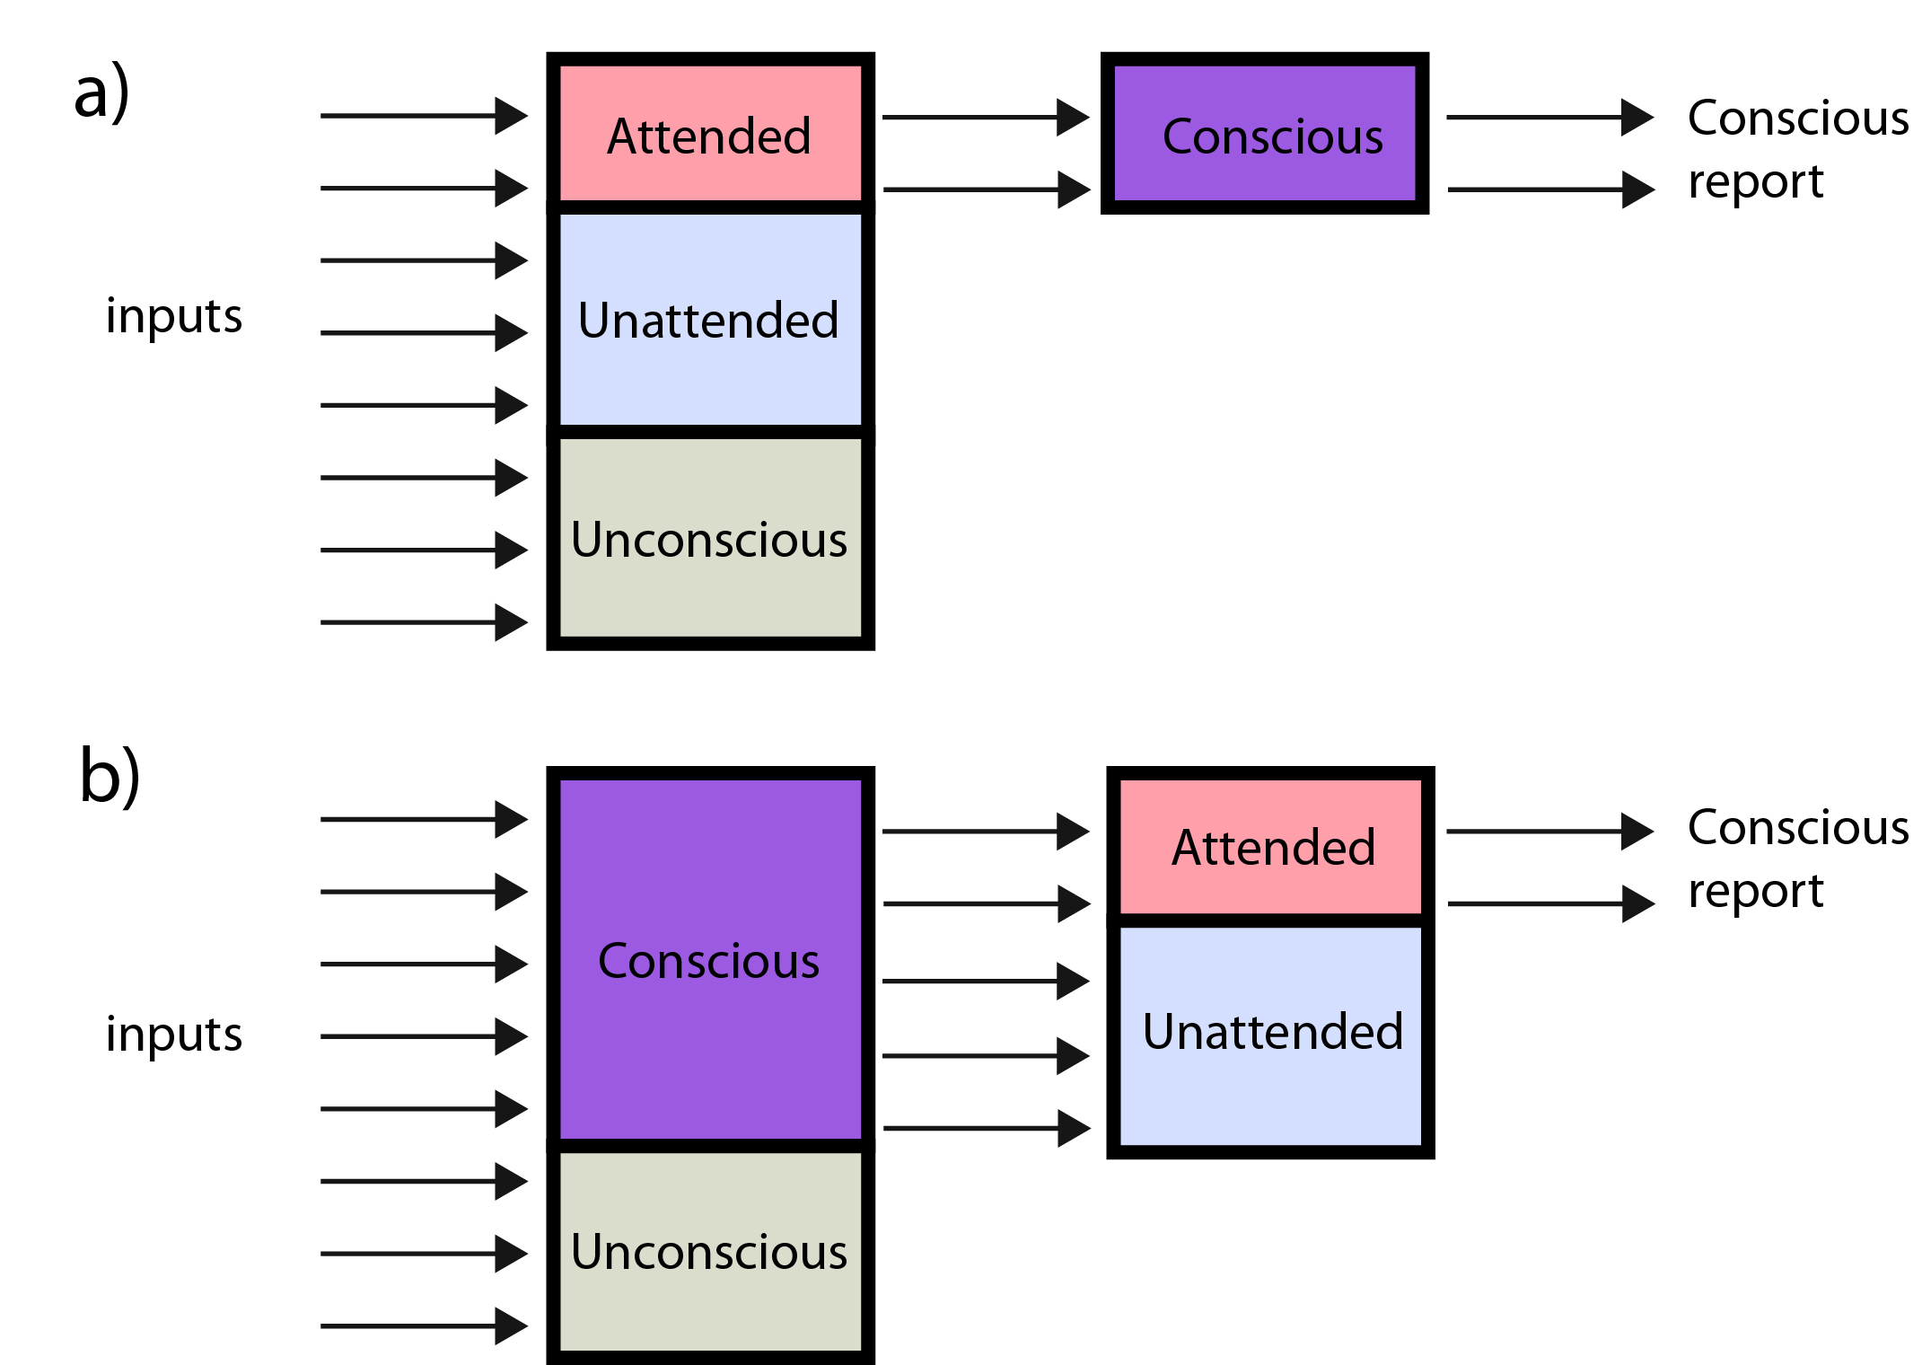

*Figure 3*. Two distinct models of consciousness, adapted from Lamme (2003). (a) A model consistent with sparseness: in this model, only information that is attended to is thought of as conscious, and available for conscious report. All other information is not available to consciousness or conscious report. (b) A representation of phenomenal and access consciousness: in this model, the information that is attended to represents access consciousness, and consists of what is available to conscious report. The information that is unattended is still conscious, even though it is not available to report unless accessed by cognitive mechanisms such as attention, and therefore forms the contents of phenomenal consciousness. It is important to note that even in a richness model, not all sensory information (inputs) is consciously processed, as there are still unconscious processes (e.g. reflexes).

Similar results have been demonstrated in an altered Sperling paradigm (see Figure 4) via measurement of participants’ estimation of colour diversity[11]*, using coloured letters (Bronfman, et al., 2014). These results suggest that colour diversity is registered and processed outside focal attention, without consuming additional working memory resources. Since working memory is a mechanism often referenced as being responsible for access consciousness (Luck & Vogel, 1997; Sligte, et al., 2008), findings by Bronfman and colleagues (2014) further imply that at least some level of conscious processing can occur outside access consciousness.

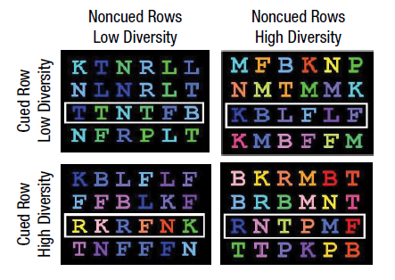

*Figure 4***.** Bronfman and colleagues’ (2014) altered Sperling (1960) letter array. Stimuli were presented in an array in which one row was pre-cued (illustrated by the white rectangle). The ‘Low Diversity’ blocks show a range of very similar colours, and the ‘High Diversity’ blocks show a range of highly distinct colours. Participants were asked to recall the letters in the cued row. They were then retrospectively asked whether the colour diversity of the cued row or the non-cued rows was low or high. Participants were able to both recall the letters in the cued row, and judge the colour diversity of the cued and non-cued rows at greater than chance levels; even when only attending to the cued row.

Additional support for phenomenal consciousness comes from findings demonstrating that top-down attention and consciousness may be distinct phenomena that need not occur together (Koch & Tsuchiya, 2007; Lamme, 2003), meaning that, limited or even no attention is required for consciousness (Aru & Bachmann, 2013; Pinto et al., 2017). These findings pose difficulties for sparseness theorists (Cohen et al., 2016), who claim that cognitive mechanisms such as attention are what give rise to consciousness in the first place.

Alongside a range of other studies, including change-detection procedures with objects (Becker, Pashler & Anstis, 2000; Landman et al., 2003), and natural real-world scenes (Clarke & Macke, 2015), these findings demonstrate existence of a high-capacity iconic memory, containing information about many aspects of a scene, for as long as 1000ms (Clarke & Macke, 2015).

**High-capacity information processing persists after visual masking**

An important facet of iconic memory, termed retinal or visual persistence (Dick 1974; Niesser, 1967; Phillips, 2011), is reported as experience of a visual stimulus continuing to be phenomenally present for some time after its physical offset, much like an afterimage (Dick 1974). This is thought to occur due to continued activity of neurons in the visual system that respond when a visual stimulus is present, after offset of an image (Coltheart, 1980; Phillips, 2011). However, retinal persistence is susceptible to visual masking (Potter, 1976). A suitable masking stimulus presented after the target is thought to overwrite the ‘icon’ (persisting visual stimulus) and consequently terminate persistence of the previous stimulus (Keysers, Xiao, Foldiak, & Perrett, 2007). While findings of previous experiments looking at iconic memory support richness, participants may have been relying upon retinal afterimages to make judgements, rather than recalling information from physical offset of the image. Proper masking methods should be included in any experiments claiming to support high-capacity phenomenal consciousness.

Importantly, while visual persistence may be vulnerable to masking, Coltheart (1980) demonstrates that information processed during image presentation may persist even after masking. Due to the high-capacity nature of iconic memory and potential persistence of information carried within it, it may be possible for participants to report on much more than just the number of items they can recall (Rensink, 2014). These findings contribute to a growing body of literature suggesting that previous paradigms underestimate the amount of information available to conscious report from brief exposures to natural scenes.

**How Quickly can we Process Information?**

A number of early influential works support the idea that humans can consciously extract a large amount of information from scenes with presentation durations as low as 100ms (Potter, 1976; Biederman, Rabinowitz, Glass & Stacy, 1974). More recent findings suggest that, when viewing a scene for less than 250ms, participants are able to name it on a semantic level (Potter, 1976; Wu, Croutez, Thorpe & Fabre-Thorpe, 2014), to categorize it (Torralbo et al., 2013), to name superordinate categories of objects and animals (Fei-Fei et al., 2007), to understand spatial properties such as depth (Greene & Oliva, 2009), and even to rate a scene aesthetically (Kaplan, 1992). Some studies demonstrate that we can categorise or detect animals, vehicles, food-objects and human or animal faces in natural scenes quickly and accurately, even when the scene is presented for only 20–25ms (Rousselet, Mace, & Fabre-Thorpe, 2003; VanRullen & Thorpe, 2001).

Nonetheless, the ability to recognise and categorise characteristics of an image varies, based on length of presentation of that image. For instance, Potter, Wyble, Hagmann & McCourt’s (2014) findings indicate above chance-level performance at as low as 13ms, when participants were asked to determine if a certain word was present in a sequence of images. Performance increased to between 70% and 90% as duration increased from 13ms to 80ms. Fei-Fei et al. (2007) found similar results for recognition of objects (including animals), increasing from poor performance at 27ms to above-chance levels at 53ms and above; even with image masking. Fei-Fei and colleagues also demonstrated reporting of sensory- or feature-level information of a scene (such as shading and shape) consistently precedes the reporting of the semantic-level information. This suggests participants in their study may have selectively processed certain types of information at extremely quick durations, and consequently, when asked to describe a scene retrospectively, may have had better access to those features over other semantic information.

These works, together with studies endorsing phenomenal consciousness and iconic memory, form a growing body of literature offering further support for a high-capacity consciousness that precedes visual-short term memory (Block, 2014; Clarke & Macke, 2015). Lamme (2003) has concluded from such studies that conscious experience is entirely determined within 100-150ms following presentation of the stimulus. Whether or not this is true, we are still left with the question of how much information can be consciously processed from a scene in a brief duration.

**Bandwidth of Sensory Input vs Bandwidth of Consciousness**

Through our sensory experience of the world, the human body processes between 11-14 million bits[12]* of information per-second (Norretranders, 1998; Zimmerman, 1986). This estimate is drawn from neural pathways in visual, auditory, tactile and olfactory sensory systems, highlighting the enormous processing power our senses use to interpret the world around us. Information can be conceptualised as a reduction of uncertainty[13]* (Shannon, 1948), meaning a decision or action which reduces the uncertainty about an outcome occurring will be informative. For instance, we know that neuron X fires if neuron Y fires; once neuron Y fires, the uncertainty of neuron X firing is reduced to zero, as it must also be firing. If such a decision is made between two options – equivalent to the firing/not-firing of a neuron, or making a yes/no or heads/tails judgement, and so on – 1 bit of information is processed.

Despite the massive amount of sensory information people process, as well as conflicting theories and findings, a severely limited bandwidth of consciousness (BOC) is the dominant view in psychology and consciousness research (Gray, 2002; Pierce, 1980; Norretranders, 1991; Zimmerman, 1986). In previous paradigms, BOC is defined as the amount of information consciously processed and reported on by an individual (Norretranders, 1998). Amount of information is measured in *bits*, which represent accuracy of decisions made between two alternatives (Zimmerman, 1986). Information Theory employs a base-2 logarithm (log2) to quantify bits of information (Attneave, 1955; Garner & Hake, 1951; Klemmer & Frick, 1953), as it calculates a binary solution (e.g. zero or one; yes or no; heads or tails)[14]. In previous experiments, if participants view an image for one second and can correctly discriminate presence of one item via a yes/no judgement, they have correctly extracted one bit of information per-second from the scene.

A number of pioneer studies in the 1950s employed information theory in attempt to quantify how much information people can consciously process. For instance, Hyman (1953) placed eight lights before a participant, providing a monosyllabic name for each light, which the participant memorised. After a brief warning signal, one of eight lights flashed on at random, with equal likelihood amongst all lights. Participants were asked to name the light that flashed. In this case, since there were eight on/off judgements to be made, the amount of information was log2(8), or 3 bits. The equation used to measure information, taken from information theory, is -log2(*p*), where *p* is probability of occurrence (Shannon, 1948). When only seven lights were used, information dropped to 2.81 bits, with six lights, 2.58, and so on, down to 1 bit when using only two lights. There was always some response time (latency) between the light flash and participants’ naming of the light. When more lights were used, there was an increase in latency (around 0.15 seconds) proportional to increase in information (i.e. from 1 bit with two lights to 3 bits with eight lights; Pierce, 1980). It took 0.15 seconds to respond to 1 bit of information, therefore Hyman estimated BOC capacity at 1/0.15, or 7 bits/sec.

Employing different paradigms, with the same method of calculating bits/sec, a variety of studies have yielded a wide range of BOC estimates, ranging from 3 bits/sec (Garner & Hake, 1952), to 5.5 bits/sec (Hick, 1952), 18 bits/sec (Gray, 2002), 25 bits/sec (Quastler, 1955), 40 bits/sec (Zimmerman, 1998), up to a maximum of 44 bits/sec (Pierce, 1980).



*Figure 5.* Two versions of the same natural world scene. The left image has been reduced to contain approximately 50 bits of visual information (16 squares, with around 10 different colours, corresponding to approximately log2(10) or 3.3 bits per square) while the right image, taken from the Nishimoto (2015) image set, contains over 300,000 bits of information in pixels (approximately 50,000 squares or pixels, with around 100 different colours - as a conservative estimate - corresponding to log2(100) or 6.6 bits per square). This is the approximate amount of information without even counting correlations and spatial relationships between different pixels, which would increase that estimate even further. The visual field of consciousness is likely not made up in the same way as pixels, however this figure demonstrates visibly the comparison being made between the amount of information our senses take in (right image), and what is argued as the information available to our consciousness (left image). When viewing a movie consisting of individual frames made up of the left image, it is unlikely that we would remember much about what we saw other than abstract colours. Contrastingly, when viewing a movie consisting of frames made up of images like the right, we would easily be able to report seeing people walking in a park with tall buildings in the background. As such, even if we are only conscious of a fraction of the information in the right image, it is hard to believe we only perceive as much information as in the left image - which is what previous estimates of consciousness seem to suggest.

Given these BOC estimates, it seems we have conscious access to only about one-millionth of information our sensory organs rely on daily to function (Gray, 2002). These findings seem consistent with advocates of sparseness, including Cohen and colleagues’ (2016) view of richness as illusory. While it is unlikely that all sensory information becomes conscious, these estimations are still completely contrary to our subjective impression of a highly rich world (Block, 2011; Tononi, Boly, Massimini & Koch, 2016). Furthermore, if we can only consciously process less than 50 bits/sec, it seems counterintuitive to have televisions that transmit four million bits/sec, or telephones that can transmit around four thousand (Norretranders, 1998). Figure 5 shows a visual representation of the discrepancy between a stimulus containing a maximal estimate of around 44 bits and a real-world natural scene. To be able to produce subjective experience of richness when looking at a scene, it seems, at least at first glance, as though we must also be able to process most if not all of the information in it. This raises the question, why is this richness not captured by measurements of previous paradigms?

**Introspection as a Tool for Measuring Visual Information**

Cohen et al. (2016) argue that introspection[15]* is a poor tool for investigating experience, and therefore richness cannot be captured through its use. One example which supports this claim is given by Lau and Rosenthal’s (2011) review regarding research into colour vision in the peripheral visual field. They infer that since there is a lower density of cones in these peripheral areas, colour vision should be weakened or non-existent in them, and greater in the foveal visual field. In other words, only in the fovea is information detailed and rich (Dennett, 1991). According to Cohen and colleagues (2016), this evidence endorses the idea that introspective reports of rich experience ought to be rejected.

**Methodological Limitations of Previous Paradigms**

Haun and colleagues(2017) offer an alternative explanation for a lack of measured richness. They claim that, rather than introspection being a poor tool to investigate experience, past experiments which quantify participants’ reports fail to capture richness due to methodological issues. Controlled experiments that focus on what participants can report about their experience provide inaccurate estimates of the amount of information processed by our consciousness. Gregory (1987) points out that participants in previous bandwidth experiments were still conscious of other unrelated things while performing experimental tasks. For example, participants seeing flashing lights in Hyman’s (1953) experiment would have seen other things aside from flashing lights. Gregory concludes it would be impossible to design an experiment that measured them all in some way. Tononi and colleagues (2016) agree, suggesting that aspects of a scene such as the immense number of spatial locations or regions which it contains, as well as their topographic relations to one another, are seldom included in experiments looking at contents of consciousness. This claim is supported by findings demonstrating that when participants view a Sperling task scene, they can effortlessly report it contained letter-like objects, distinct from other items taking up the same space (De Gardelle, et al., 2009).

Furthermore, participants can also report with high confidence what they did notsee in a scene (Haun et al., 2017), whereas previous measurements only considered reports on presence of objects or their categorization in a scene. Haun and colleagues claim that these limitations are part of the reason we cannot measure richness in a controlled experimental setting. In other words, limited capacity of visual experience inferred from tasks such as change-detection and inattentional blindness, is due to methodological problems with these paradigms, rather than with introspection itself. Haun et al. (2017) conclude that there is no *prima facie* reason to doubt an individual’s subjective report of a colourful or rich experience.

**Overcoming Methodological Limitations: Psychophysics**

Introspective reports of rich visual experience are supported by psychophysical evidence (Haun et al. 2017). Psychophysics[16]* quantitatively investigates the relationship between physical stimuli and sensations they produce (Gescheider, 1997). A range of psychophysical paradigms were used in previous studies to quantify accuracy of introspective reports, allowing researchers to test additional informative aspects of a scene with a solid psychological basis(Haun et al., 2017). For instance, claims by Lau and Rosenthal (2011) about colour vision are contradicted by a number of psychophysical studies (Anstis, 1998; Haun et al., 2017). Most recently, Tyler (2015) published demonstrations of the vividness of peripheral colour through arrays of multi-coloured disks, linearly scaled with eccentricity (see Figure 6).

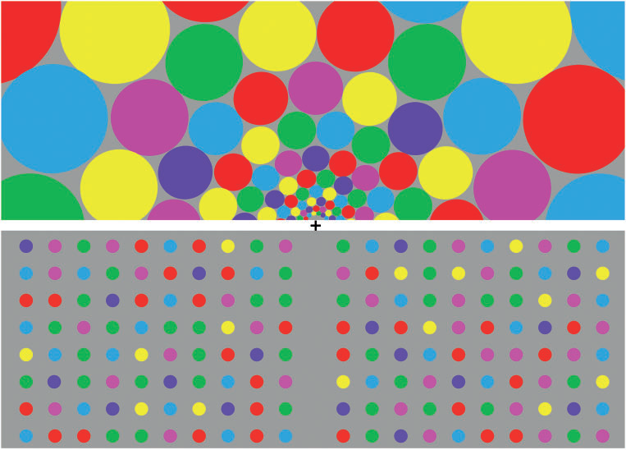

*Figure 6*. Tyler’s (2015) peripheral colour demo. When staring at black fixation cross in the middle of the image and focusing on the top half of the image, colour can be perceived with much local spatial detail even in the peripheral visual field. This is because the images are scaled according to a cortical magnification factor. Contrastingly, when focusing on the bottom half, the coloured dots in the periphery seem to lose colour and detail. These dots have not been scaled.

Tyler suggests that reports of lack of colour in the periphery are due to scaling inconsistencies and improperly scaled stimuli, rather than a lack of ability to perceive colour. When images are scaled according to a cortical magnification factor, colour can be perceived with much local spatial detail even in peripheral visual fields (Pelli and Tillman, 2008; Tyler, 2015). Similar to Tyler’s findings, introspective reports of a richly detailed visual experience are often supported by solid psychophysical evidence, despite contrasting claims (Haun et al., 2017).

A recent study by Vandenbroucke and colleagues (2014) employing a psychophysical paradigm called ‘metacognition’, further supports the efficacy of introspective reports. Metacognition reflects correspondence between participants’ objective accuracy[17]* and their confidence in their accuracy (Fleming, Dolan & Frith, 2012). Objective accuracy reflects how effectively participants can discriminate objective states of the world (Fleming & Lau, 2014; Meuwese, van Loon, Lamme & Fahrenfort, 2014), whereas confidence rating is a ‘meta’ judgment about their own decision process (i.e. thinking about thinking), giving rise to the term metacognition (Klein, 2015). Using this paradigm, Vandenbrouck et al. (2014) showed that working memory and iconic memory are both equally accessible to introspection.

A study by Kaunitz et al. (2016) used metacognition to demonstrate that memory for incidental visual experience of non-target faces in crowds is far better than would be expected if consciousness was illusory. The ability to recall faces which participants were not actively looking for in a crowd supports richness of visual experience, by demonstrating information processing outside of active awareness (or access). While the Sperling partial-report paradigm can only really be applied to scenes consisting of arrays of letter-like objects, Kaunitz and colleagues’ study provides support for richness in a range of real-world natural scenes.

To our knowledge, even those studies employing metacognition or other psychophysics approaches to quantify introspection do not provide an exact measure of the amount of information humans consciously process, simply stating that it must be large (e.g. Potter et al., 2014; Vanderbroucke et al., 2014). Consequently, we are left with literature dominated by estimates of BOC as severely limited (up to 40 bits/sec), and filled with studies plagued by methodological limitations. A way of combining the quantification process used by experiments that support sparseness, with promising results of studies that demonstrate conscious processing of a large amount of information, would provide a measure that matches up with our subjective experience of the world as rich.

**Present Study**

Previous studies providing estimates of BOC fail to consider factors such as what is absent from a scene. These factors still constitute information, but have been entirely overlooked in the literature. Additionally, previous paradigms such as the Sperling (1960) task do not take into consideration the range of details across natural scenes. This study aims to address these factors, in order to provide a more accurate measure of the amount of information people can extract from a brief exposure to a natural scene.

Furthermore, when calculating estimates of BOC, previous studies have not manipulated duration of presentation of scene images. The rate of information processing is unlikely to be constant across a range of image durations, due to people’s variable performance at different durations demonstrated by previous findings (Fei-Fei et al., 2007; Potter et al., 2014). Based such findings, the current study further aims to investigate changes in BOC during varying durations of image presentation.

To achieve our aims, we will implement a suggestion by Haun et al., (2017) for overcoming previous methodological limitations, which lead to inaccurate measures of introspection and richness. Specifically, we will ask people to report about aspects of a scene that are absent, as well as those present. In order for individuals to report on aspects of a visual scene, they must have conscious access to information in the image which is related to those aspects. We employ a psychophysics paradigm to collect confidence ratings and measure objective accuracy. We will use these measures to estimate the amount of information participants can consciously access for both present and absent aspects of a scene, which we call BOC. If we can account for some limitations in previous paradigms highlighted by Haun et al., (2017) can we reveal massive BOC to support our experience of richness?

Based on this question, we hypothesised that, when considering both descriptions of a scene that are present as well as those absent, BOC average across participants will be significantly higher than 40 bits/sec. We further hypothesised that participants’ accuracy and confidence will increase as image duration increases.

**CHAPTER 2: METHODS AND RESULTS**

**General Methods**

We conducted three experiments in this study. We first explain the general methods shared by all three experiments, followed by experiment-specific information.

**Participants**

Ethics approval was obtained from the Monash University Human Research Ethics Committee, and written informed consent was obtained from all participants (see Appendix B for ethics forms). This study was completed in accordance with approved guidelines.30 volunteers (18 female and 12 male) participated in our study (10 in Experiment 1, 15 in Experiment 2, and 5 in Experiment 3). Inclusion criteria was native English speaking, and normal or corrected-to-normal vision. Participants’ ages ranged from 19-28 (*M* = 22.37, *SD* = 1.99).

**Materials**

Participants were seated in a well-lit room designed for psychophysics experiments. They were seated at a viewing distance of 114cm from a VIEWPixx/3D computer monitor (1920x1200 pixels, 120Hz), connected to a Ubuntu v14.04 computer. All experiments were programmed and conducted using MATLAB with Psychophysics 3 Toolbox (Brainard, 1997; Kleiner, Brainard & Pelli, 2007). Microsoft Excel with KUTOOLS (2017) and Python v2.7 were also used to prepare image description stimuli.

**Stimuli**

**Images**

Images were taken from a series of short videos by Nishimoto (2015). A total of 9120 still-frame images were captured as screenshots from the videos. We manually selected 570 images that portrayed unique scenes; the rest were discarded as they portrayed similar content to the chosen images. Figure 7 shows examples of range and type of images used.

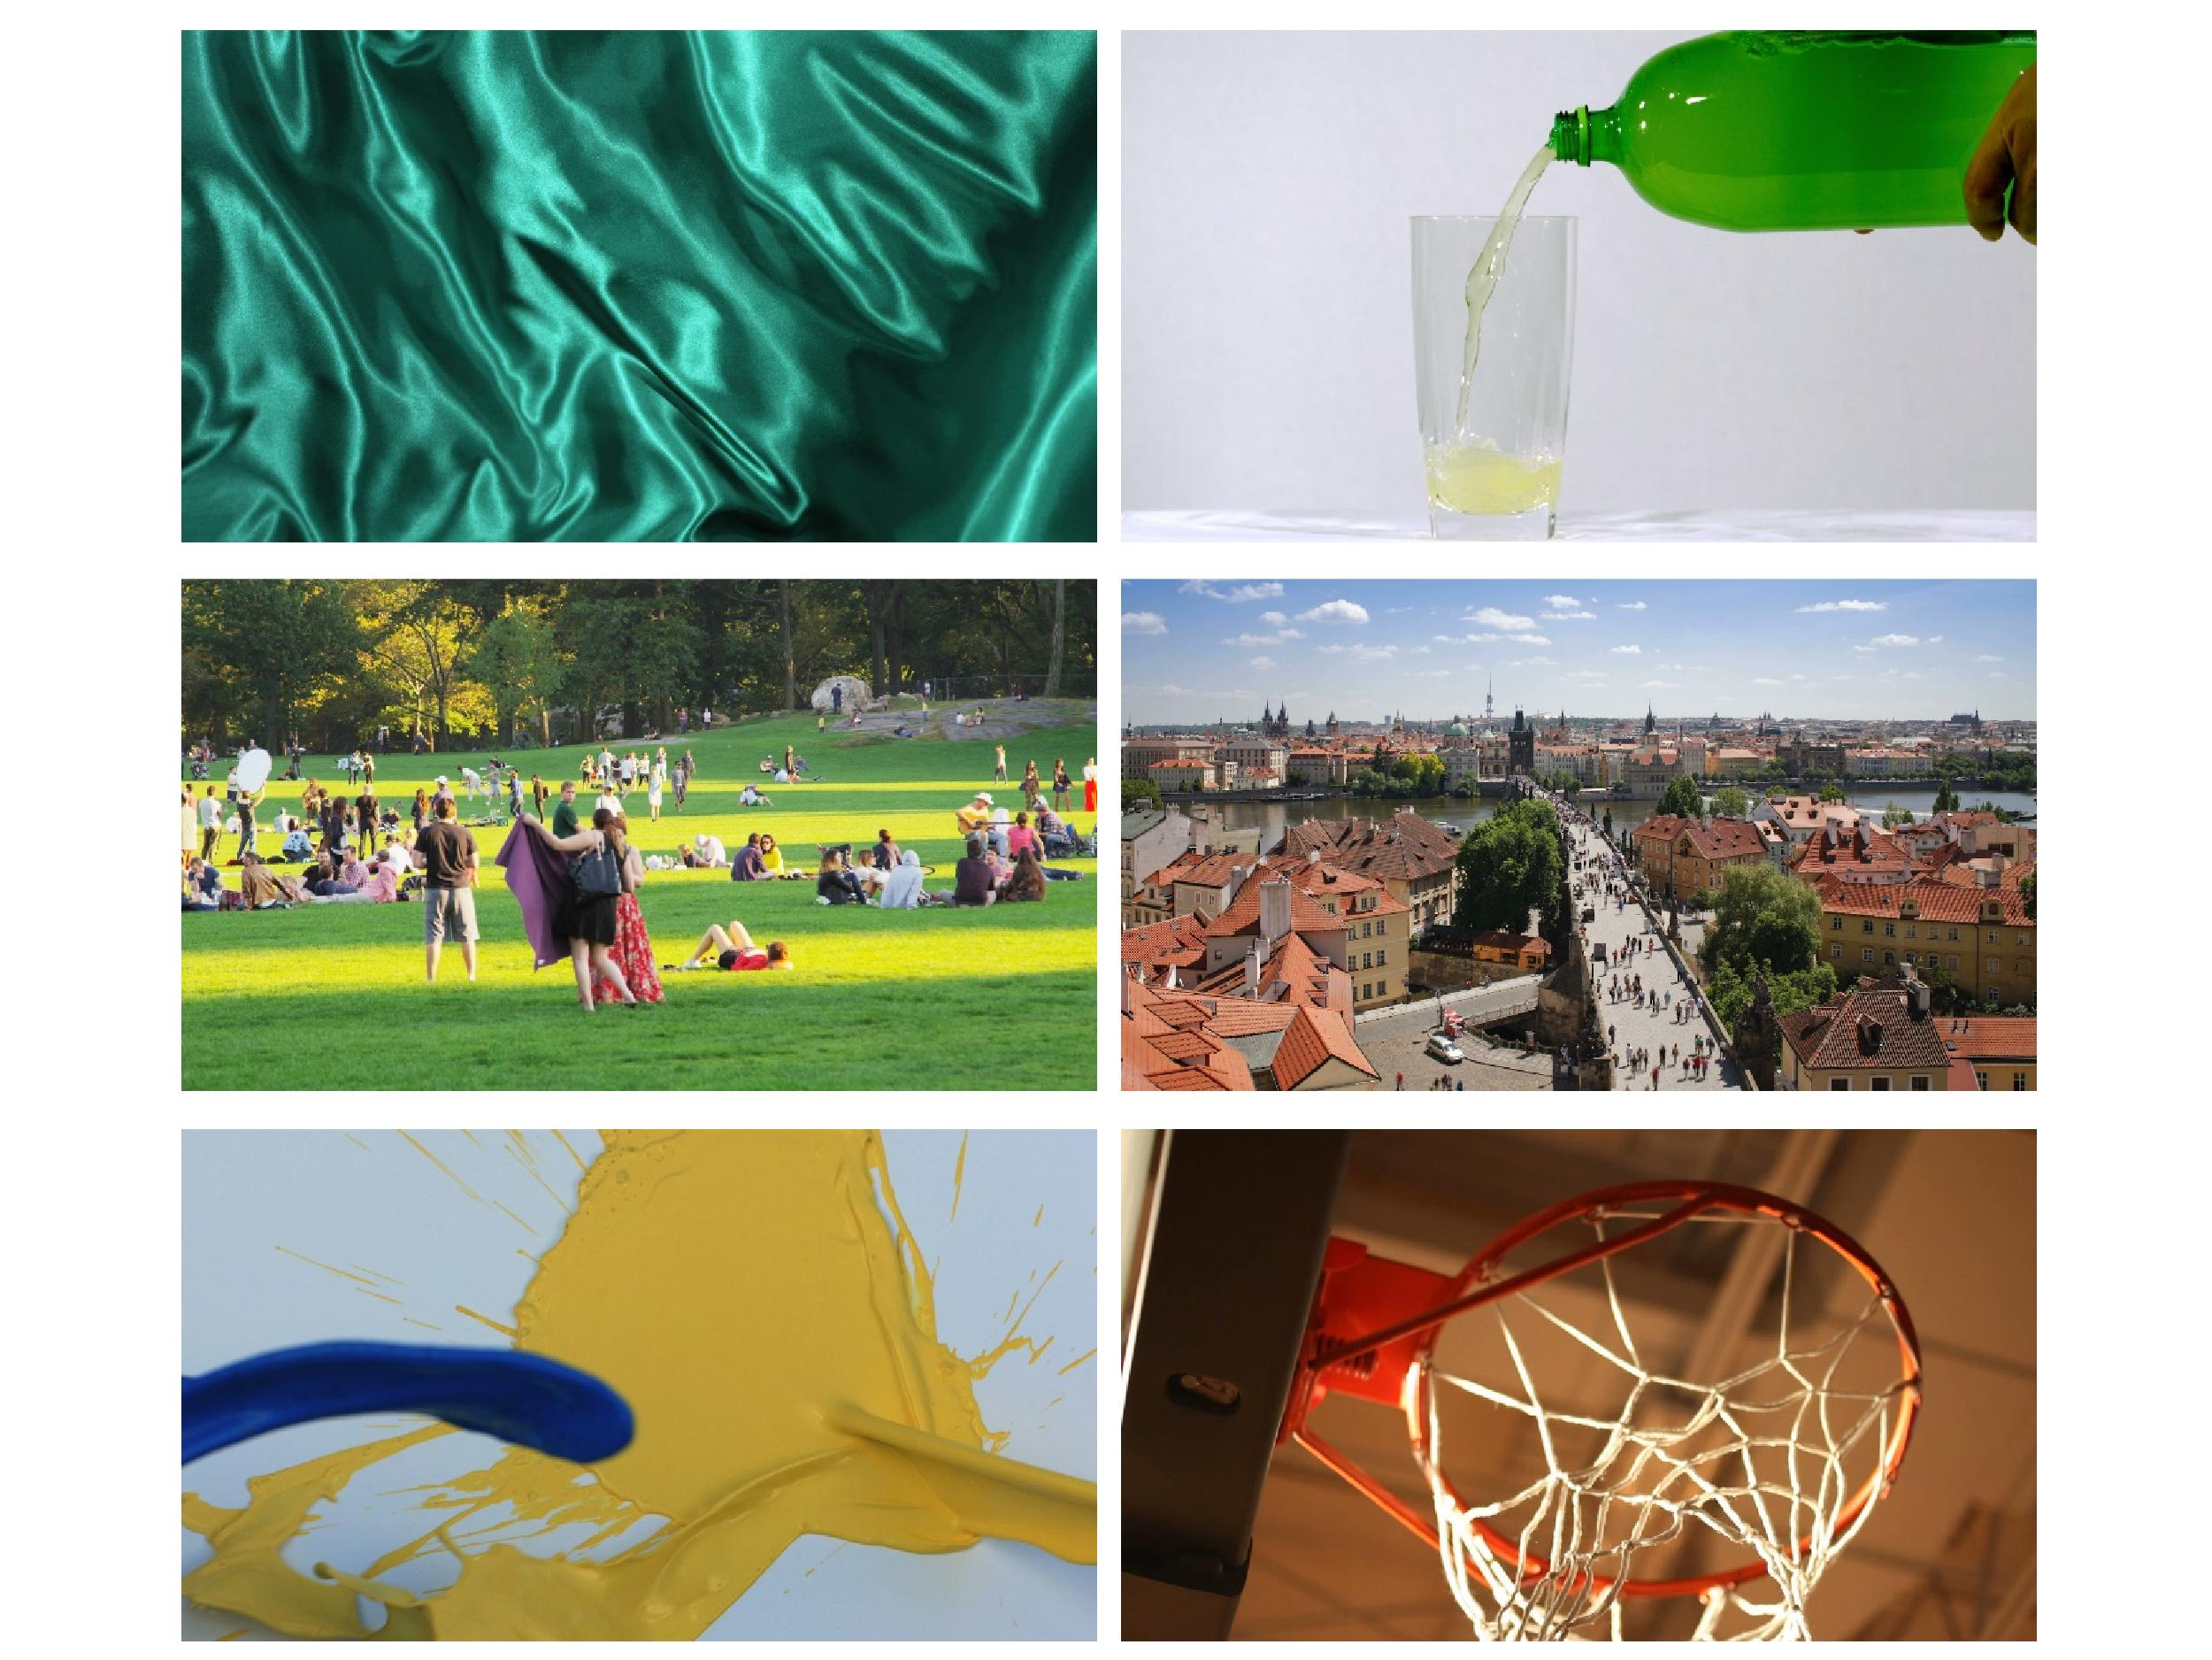

*Figure 7***.** Six example natural scene images taken from the Nishimoto (2015) dataset, used in the current study. Some scenes, such as those shown in the top and bottom left images, contain aspects that are difficult to report on if asked only about present aspects. In order to describe their rich detail, reporting other aspects of the scene, such as colour, spatial orientation or absent concepts, would be required.

**Image descriptions**

Each image was accompanied by free-flowing descriptions collected in an unpublished study (Nishimoto, 2015). Nishimoto asked 40 participants to provide unique descriptions in free-flowing paragraphs, in up to 50 (Japanese) characters. Four-five unique participants (‘raters’) provided descriptions for each image. No time limits were imposed on raters when describing each image.

As all descriptions were from Japanese participants, we translated them via Google Translate (2017). Descriptions were split into individual words (‘descriptors’), and cleaned of non-alphabetical characters and symbols. The Natural Language Processing Toolkit (Loper & Bird, 2002) was used with Python 2.7 via MATLAB to remove plurals and ambiguities. We also removed many inflectional endings to return the base or dictionary form of a descriptor (Manning, Ragvhan, & Schutze, 2008). We carried out a number of manual processes to further clean descriptors.

Firstly, we removed descriptors that were determined to be nonsensical or improperly translated from Japanese by Google Translate (e.g. ‘defeganta’ or ‘zazen’), and descriptors that had a specific meaning in Japan only (e.g. ‘Shinkansen’ or ‘Yamato’). Furthermore, we changed any use of the descriptor ‘foreigner’ to ‘person’ to account for cultural differences between Japanese raters and participants in the current study.

Secondly, of the 250 most commonly-used words in the English language (Gilner & Morales, 2005; Kress, 1993), we removed all descriptors except nouns, adjectives, verbs and adverb (words such as ‘a’, ‘and’, ‘the’, and ‘is’). A total of 253 descriptors were removed from task construction (see Appendix A for full list).

Third, after cleaning descriptors, we counted the frequency of remaining descriptors for each image. If one rater used ‘water’ four times in their description, we only counted one use of ‘water’ for that rater. If three of four raters all said ‘water’, we counted that as three unique ratings of ‘water’ for the image being described (see Appendix A for top 100 most common words across raters). Figure 8 shows rating frequency of descriptors across images.

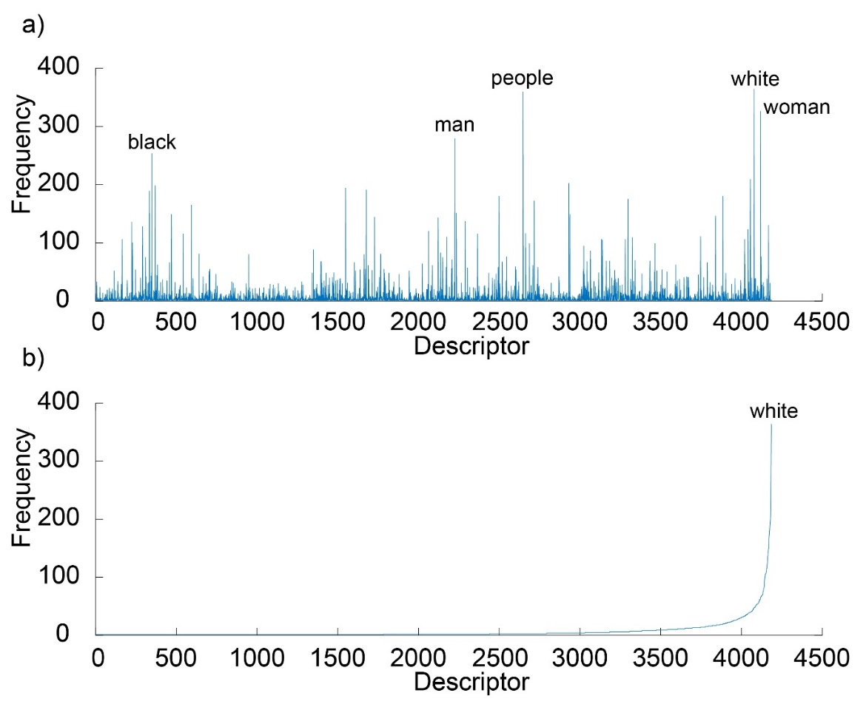

*Figure 8.* Frequency distribution showing the number of times across images at least one rater used a specific descriptor. Each blue line represents a unique descriptor. a) Descriptors sorted by alphabetical order. The top five most commonly used words are shown above the highest frequency lines. b) Descriptors sorted by frequency, from lowest to highest.

Lastly, we determined that a descriptor was objectively ‘present’ in an image if at least two independent raters used it to describe that image. If only one rater used a certain descriptor to describe the image, it was not considered present. If zero raters used a certain descriptor to describe the image, it was considered ‘absent’ from that image. Our criteria provided a total of 499 possible images for the experiment. We also tested at least three raters or at least four raters, which only provided 77 and 76 images respectively. We chose the criteria of at least two raters to ensure a larger number of trials for all 3 experiments.

Furthermore, we included only images with at least four possible present words. We chose this criteria to ensure that we could ask participants multiple present questions for each image without doubling up on descriptors for each participant. This left a total of 499 of the original 570 images with at least four possible present answers, and a total of 4186 unique descriptors, each used by at least two raters to describe one or more images.

**Procedure**

Prior to commencing the experiment, participants completed 2-6 practice trials. Participants clicked the mouse button on a prompt screen. A fixation cross was then presented in the centre of the screen for 250ms, and participants were instructed to look at it. An image was then displayed on the screen for a predetermined duration of time. Image duration varied across all three experiments. Order of images and type of descriptor were randomised for each participant for each trial. Figure 9 illustrates a single experimental trial.

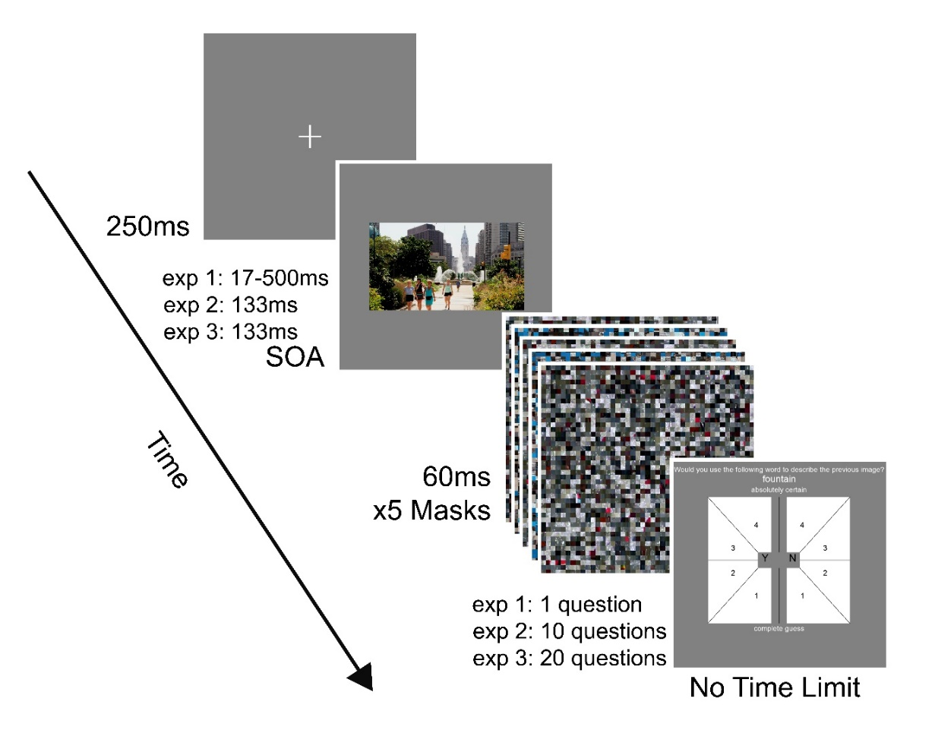

*Figure 9***.** General experimental setup, showing an overview of a single trial. A fixation cross indicated the start of the trial, followed by a brief image presentation. In Experiment 1, participants were shown images at six different durations, or stimulus onset asynchrony (SOA), ranging from 17ms to 500ms, randomly intermixed within each block. In Experiment 2 and 3 participants were only shown images at 133ms duration. Following​ ​a​ ​short​ ​delay both central​ ​and​ ​peripheral​ ​targets​ ​were​ ​masked with 5 unique jumbled images. Subjects were then presented with a screen asking ‘would you use the following word to describe the previous image’, with the word below. They made​ ​an​ ​8-alternative forced choice (8AFC)​ ​response​ ​with​ ​a​ ​single mouse-click,​ ​signalling​ ​their​ ​presence judgment​ ​(‘Y’​ ​for​ ​yes​ ​or​ ​‘N’​ ​for​ ​ ​no)​ ​and 4-level​ ​confidence​ ​rating. For Experiment 1, participants were presented one descriptor question for each trial (e.g. the word ‘fountain’). For Experiment 2, participants were presented with 10 descriptors, one after the other, for each trial. Experiment 3 was the same as Experiment 2, however participants were presented with 20 descriptors for each trial.

Participants were shown 499 trials for Experiment 1, 180 trials for Experiment 2 and 90 trials for Experiment 3, split into six equal blocks. Participants were allowed to rest between each trial, and designated rest times were allocated at the end of each block. After an image was shown, five visual masks were presented in quick succession, each with a duration of 60ms, for a total of 300ms, to suppress any retinal persistence of the image (Dick, 1974). To ensure proper estimates of image duration, we measured stimulus onset asynchrony (SOA), or time between image onset and mask onset, which is an accurate representation of the duration participants saw the image (Shevrin, 1996). Participants were then presented a screen with a descriptor at the top (e.g. ‘fountain’), and two rectangles below. The rectangles were split into four equal sections numbered 1-4 on each section, and ‘Y’ or ‘N’ on the left and right rectangles, respectively. Above the descriptor, participants were prompted with the question “Would you use the following word to describe the previous image?” Participants were instructed to extend this question to any aspect of the image. They indicated their agreement by clicking on the range of values indicated by ‘Y’ for yes, or disagreement by clicking on the range of values indicated by ‘N’ for no. We defined a statement of yes as participants believing a descriptor was present in the image, and a statement of no as participants believing it was absent.

Accuracy and confidence ratings of participants’ responses were recorded for each trial. Participants were given as long as they required to select their response. On average it took just 2.21 seconds to respond, from the moment the response screen was shown until participants clicked one of eight sections. Confidence ratings were collected to provide insight into participants’ conscious processing. Instead of simply making a yes/no judgement, participants also had to indicate how sure they were of their answer, providing an indication of what information was actually consciously available to them (Kaunitz et al., 2016).

**Data Analysis**

All raw data was analysed through MATLAB R2016a.

**Signal detection theory**

To estimate participants’ ability to discriminate between objectively present and absent descriptors (i.e. sensitivity), we adopted signal detection theory (SDT; Macmillan & Creelman, 2005) to estimate Type-1 performance (objective accuracy). We first collected frequency of responses for each participant and each SOA. Table 1.1 shows frequency of responses for a participant that performed with high sensitivity, and Table 1.2 provides an example of the same participant at a different SOA, performing with poor sensitivity.

Table 1.1

*Frequency of responses for 83 trials, for participant JP at 133ms SOA*.

|  |  |  |  |  |  |  |  |  |
| --- | --- | --- | --- | --- | --- | --- | --- | --- |
|  | Present Responses (‘Yes’) | | | | Absent Responses (‘No’) | | | |
|  | 4 | 3 | 2 | 1 | 1 | 2 | 3 | 4 |
| Present | 12 | 10 | 5 | 4 | 0 | 3 | 3 | 3 |
| Absent | 0 | 0 | 1 | 3 | 6 | 9 | 10 | 15 |

Note: values in the second row (4-1, and 1-4) represent participants’ confidence ratings. A confidence rating of 1 indicates a complete guess, while a confidence rating of 4 indicates that the participant was completely certain in their response. The ‘Present’ row reflects objective presence of a descriptor, while the Present Responses columns reflect participants’ subjective judgement of presence of the descriptor.

Table 1.2

*Frequency of responses for 83 trials, for participant JP at 17ms SOA*.

|  |  |  |  |  |  |  |  |  |
| --- | --- | --- | --- | --- | --- | --- | --- | --- |
|  | Present Responses (‘Yes’) | | | | Absent Responses (‘No’) | | | |
|  | 4 | 3 | 2 | 1 | 1 | 2 | 3 | 4 |
| Present | 0 | 0 | 3 | 0 | 32 | 5 | 1 | 1 |
| Absent | 0 | 1 | 1 | 2 | 29 | 8 | 0 | 1 |

Note: values in the second row (4-1, and 1-4) represent participants’ confidence levels. JP’s responses were mainly clustered around low confidence ratings (1-2) for ‘No’, demonstrating that they were guessing for most images at 17ms.

Using these frequencies, we constructed a Type-1 receiver operating characteristics (ROC) curve, in which we regarded a trial where the correct response was ‘yes’ as a signal-present trial. Conversely, trials in which the correct response was ‘no’ were regarded as signal-absent. ROC graphs have long been used in SDT to depict the trade-off between ‘hit[18]*’ rates and ‘false alarm[19]*’ rates of classifiers (Egan, 1975; Swets, Dawes & Monhanan, 2000). Starting from the most stringent criterion, we defined a signal-present response with confidence 4 as a hit in a signal-present trial and false alarm in a signal-absent trial (Matthews, Schroder, Kaunitz, van Boxtel & Tsuchiya, 2017). Then, in the second most stringent criterion, we regarded a signal-present response with confidence 4 and 3 in a signal-present trial as a hit and in a signal-absent trial as a false alarm, and so on. With the most lenient criterion, we considered any signal-present response and signal-absent response with confidence 1, 2 and 3 in a signal-present trial as hit and in a signal-absent trial as false alarm (Matthews et al., 2017). This way, we calculated proportions of hits and false alarms over seven possible criteria, creating a ROC with 7 inflection points (Kaunitz, Rowe & Tsuchiya, 2016; see Figure 10 for example ROC curves).

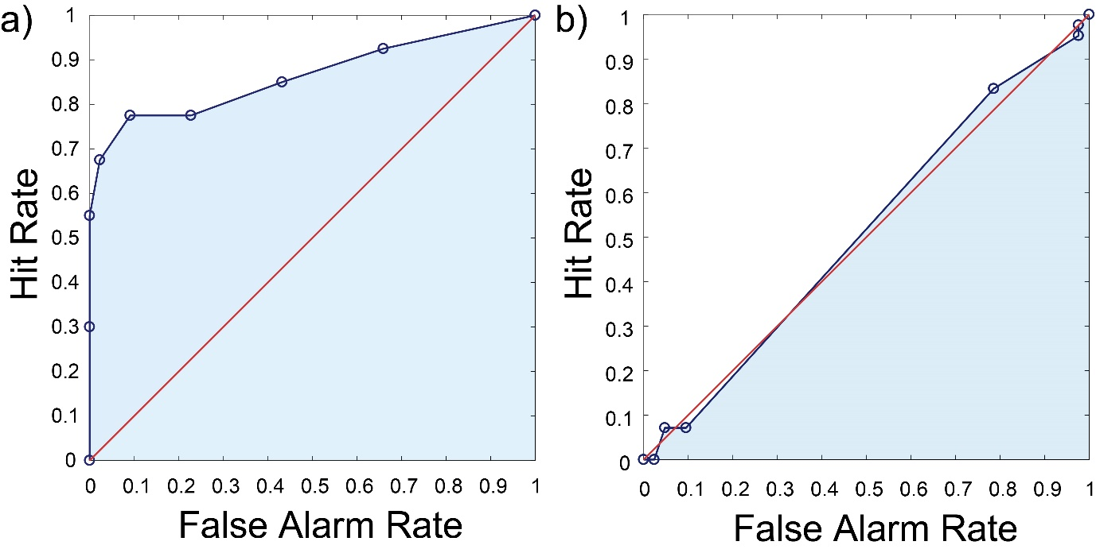

*Figure 10*. Example ROC curves of a single participant (JP) for Experiment 1. The dark blue line corresponds to a 7-point ROC curve, the red line reflects chance-level performance and the shaded light blue area represents Type-1 area under the curve (AUC). (a) 7-point ROC curve created from responses to an SOA of 133ms, corresponding to high objective accuracy. The first point (dark blue circle), at Hit Rate = 0.3 and False Alarm Rate = 0, corresponds to the participants’ objective accuracy at the most stringent criterion (‘Yes’ response with confidence 4 is classified as present, and everything else is classified as absent), the second point, at Hit Rate = 0.55 and False Alarm Rate = 0, corresponds to the participants’ objective accuracy at the second most stringent criterion (‘Yes response with confidence 3 or 4 is present, everything else is absent), and so on. (b) ROC curve at 17ms, corresponding to near-chance performance, and consequently low objective accuracy. The dark blue circles represent the same criteria as Figure 10a.

**Area under the curve (AUC): A measure of objective accuracy**

Area under the ROC curve (AUC or Type-1 AUC) [20]* was computed to provide a non-parametric estimate of objective accuracy for each experiment. AUC ranges from 0.5, reflecting chance-level performance, to 1, reflecting perfect performance. It has been used previously to measure the amount of information provided by alternative options in a diagnostic setting (Benish, 2003; Hanely & McNeil, 1983).

**Using objective accuracy to define bits/sec**

|  |  |
| --- | --- |
| $$bits= \log_{2}{(2×AUC)}$$ | (1) |

We adapted the standard equation (${\text{-log}}_{\text{2}}{\text{p}}$), used to quantify information (in bits) from information theory to our current study (Attneave, 1955; Garner & Hake, 1951; Klemmer & Frick, 1953). 1 bit of information is equivalent to a complete reduction in uncertainty[21]* (Shannon, 1948). In the original equation, complete reduction of uncertainty is gained from a probability (*p*) of 0.5. In our task, however, we do not use probability to quantify information. Instead, we use objective accuracy, which is a different measure to probability. Complete reduction of uncertainty is instead gained from an objective accuracy of 1, which reflects participants’ ability to distinguish between present and absent words with very high accuracy. An objective accuracy of 0.5 reflects no reduction of uncertainty. Instead, it represents a random classification between present and absent words, meaning participants could not accurately distinguish between the two at greater than chance levels; they were still uncertain even after making a judgement of yes or no. Therefore, we modified the original information theory equation to accommodate our Type-1 AUC measure. We used the following equation to calculate information:

**Differences Between Experiments**

In Experiment 1, we asked participants one question for each image, with 50% of questions objectively present, and 50% objectively absent. In Experiment 2, we increased the number of questions per-image to 10; 30% of those questions included present descriptors and 70% included absent descriptors. In Experiment 3, we doubled the number of questions per-image to 20; 20% of the questions included present descriptors and 80% included absent descriptors. Table 2 summarises the task differences between all three experiments.

Table 2

*Task differences between experiments in number of participants, trials, questions per trial, total descriptors and ratio of present to absent words*

|  |  |  |  |  |  |
| --- | --- | --- | --- | --- | --- |
|  | No. Participants | No. Trials (images) | No. Questions per Trial | No. Total Descriptors | Present:Absent Ratio |
| Experiment 1 | 10 | 499 | 1 | 4186 | 50:50 |
| Experiment 2 | 15 | 180 | 10 | 1543 | 30:70 |
| Experiment 3 | 5 | 90 | 20 | 776 | 20:80 |

Note: Present:Absent Ratio represents the ratio of the percentage of questions that had present descriptors to the percentage of questions that had absent descriptors for each experiment. Number of total descriptors represents the number of descriptors out of the original 4186.

**Experiment 1: Determining target SOA**

**Methods**

Our first experiment examined differences in participants’ performance among six SOA durations, when asked only one question about an image. 10 volunteers (six male, four female) aged 20-28 (*M* = 23.00, *SD* = 2.67) participated in Experiment 1. The procedure was identical to our general method. We tested six different SOAs of image presentation, calculated from the screen refresh rate of the monitor (120Hz). The six SOAs were: two-frames (17ms), four-frames (33ms), eight-frames (67ms), 16-frames (133ms), 32-frames (267ms), and 60-frames (500ms). All SOAs were randomly intermixed within each block. Different SOAs were tested based on research by Potter et al. (2014) which demonstrates that the ability to recognise and categorise characteristics of an image varies based on length of presentation. For each trial, a specific duration was randomly selected with equal chance from among six SOAs, leaving 83-84 trials for each SOA, for a total of 499 trials. Each participant contributed one confidence rating for one descriptor, for each image.

**Data Analysis**

We used Equation 1 to calculate the amount of information participants processed, for each SOA. We then divided number of bits for each SOA by duration of the SOA, in order to extrapolate the amount of information that could be processed per-second (bits/sec). This resulted in the following equation:

|  |  |
| --- | --- |
| $${bits/sec}_{SOA}= \frac{\log_{2}\left(2×{AUC}_{SOA}\right)}{SOA}=\frac{bits}{SOA}$$ | (2) |

**Results**

Average confidence and objective accuracy for each SOA are shown in Figure 11. Confidence levels increased as SOA increased, from an average rating of 1.44 at 17ms to an average rating of 3.23 at 500ms. AUC also increased as SOA increased, until peaking at 267ms with an AUC of 0.84 before decreasing again to 0.83 at 500ms.

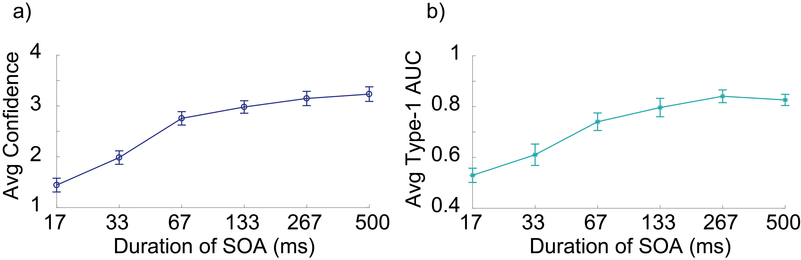

*Figure 11.* Confidence and objective accuracy levels, averaged across trials and participants. (a) Confidence ratings (mean ± standard error of the mean over subjects). Confidence increases as a function of duration from 17ms to 500ms. (b) Objective accuracy (mean ± standard error of the mean over subjects). At 17ms, the average is around chance-levels (0.50 AUC). AUC increased as a function of duration until reaching a maximum at 267ms, before plateauing to 500ms.

**Quantifying Conscious Information Processing: Bits and Bits/Sec**

Figure 12 shows how much information participants could process for each SOA (bits), as well as per-second (bits/sec). As SOA increased, the amount of information participants’ processed per-SOA increased, until plateauing at 267ms (*M* = 0.75, *SD* = 0.11). The amount of information participants could process per-second plateaued at 33ms-67ms, decreasing from 67ms (*M* = 8.37, *SD* = 2.45) to 500ms (*M* = 1.46, *SD* = 0.19).

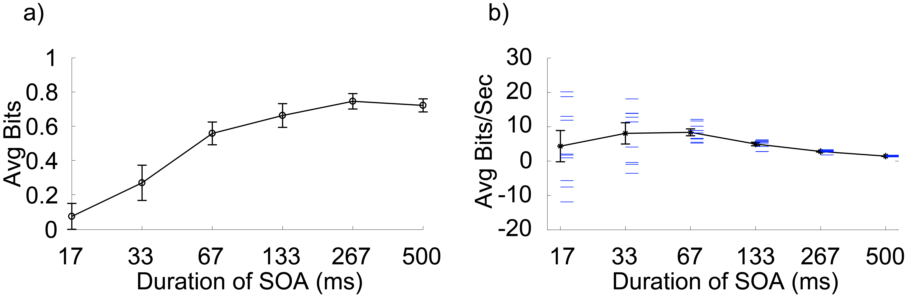

*Figure 12.* Average amount of information processed at different SOAs. (a) Amount of information (in bits) for each SOA (mean ± standard error of the mean, over subjects). As SOA increased, so too did the amount of information, until asymptoting at 267ms (b) Amount of information per-second, measured in bits/sec (bits divided by SOA). The black line corresponds to participants’ average information (bits) gained from exposure to an image (mean ± standard error of the mean, over subjects). The blue lines are participants’ actual information processing values.

**Experiment 1 Discussion[22]**

**Measuring Maximum Performance on the Task**

Recent literature has reported an increase in performance when recognising and categorising characteristics of a scene, with increasing image durations (Fei-Fei et al., 2007; Potter et al., 2014). Such findings led us to hypothesise that, in our study, participants’ accuracy and confidence will increase as image duration increases. We used Experiment 1 to test this hypothesis, and found it to be partially supported. In Experiment 1, the increase in participants’ confidence as a function of increase in duration was consistent with previous metacognition findings (Whitmarsh, et al., 2017). However, the plateau in participants’ accuracy at 133ms to 500ms is inconsistent with previous research, which shows a linear increase in accuracy from 27ms to 500ms (Fei-Fei et al., 2007). We speculated this plateau may be have been due to the ambiguous nature of some image descriptors in our study. Many words were anecdotally reported by participants as difficult to judge as either present or absent. During shorter SOAs, some participants reported not having enough time to over-think or analyse the descriptor words, and therefore relied on bottom-up, ‘gut’ feeling processes when making present/absent judgements. At 267-500ms, they may have felt they had enough time to apply top-down processing and over-think their responses rather than relying on gut feeling. Therefore, the ambiguous nature of some descriptors may have impacted participants’ performance, causing a plateau and, consequently, a ceiling-effect on maximum performance.

Due to this ambiguity, we defined maximum performance as the highest objective accuracy across all SOAs, on average. This value was 0.84, equivalent to average AUC at 267ms. Since we saw a plateau in objective accuracy from 267ms to 500ms, we concluded that, any amount of time taken to view each image at greater than 267ms would unlikely result in a much greater performance than 0.84 on average.

This interpretation may be criticised due to the fact that participants’ confidence increased as a function of SOA and did not plateau like accuracy. However, people tend to assign higher confidence to their judgements at longer durations, regardless of their actual performance (Whitmarsh, et al., 2017). We extended the objective accuracy value of 0.84 as an estimate of maximum possible accuracy for experiments 2 and 3.

**Selecting a Target SOA for Experiments 2 and 3**

We additionally used Experiment 1 results to select a target SOA for the following two experiments. Our criteria for selecting a target SOA in Experiment 2 and 3 was to find a minimum SOA while ensuring high objective accuracy. We also wanted to ensure participants were only using iconic memory while viewing the image. Results from Experiment 1 show that an SOA of 267ms would have provided the optimal time based on this criteria, given the average AUC for that duration was the highest amongst SOAs. Nonetheless, previous estimates of iconic memory suggest it may only last up to 250ms (Dick, 1974; Sperling, 1960). While more recent findings by Clarke and Mack (2015) have showed that iconic memory for natural scenes lasts up to 1000ms, we decided to be conservative with our target SOA for experiments 2 and 3, and chose a target SOA of 133ms. Nonetheless, a variety of SOAs ought to be tested in the future, to see how conscious information processing estimates are affected.

**Experiment 2: Testing Multiple Questions per Image**

The second experiment used a very similar paradigm, with few key differences. The main purpose of Experiment 2 was to test the change in participants’ objective accuracy and information processing, when extending the number of questions for each image to 10, instead of just one. The amount of information participants can report on increases for each reduction in uncertainty that can be measured; more questions asked results in more objective measures of reduction in uncertainty, and consequently more information.

**Methods**

Participants were 15 volunteers (five male, 10 female) aged 19-24 (*M* = 21.80, *SD* = 1.66). The procedure for Experiment 2 was similar to our general method, with few key differences. Firstly, we displayed all images for an SOA of 133ms. Secondly, instead of asking just one question for each image, we asked 10 questions. Three of 10 questions were present descriptors, and seven of the 10 questions were absent descriptors. The seven absent descriptors used in each image were randomly selected from the pool of present descriptors of the other 498 images. For each unique image, every participant was shown different absent descriptors; we ensured no two participants saw identical absent descriptors for each image. Furthermore, order of present and absent questions shown to participants was randomised for each participant and each image. Lastly, only 180 of 499 images (the first 180 images by image ID) used in Experiment 1 were kept as images in Experiment 2. Number of trials was reduced to 180 in order to keep the same time-frame of testing as Experiment 1, to account for potential differences in tiredness and performance of participants. The pool of descriptors was also reduced, to only descriptors used for 180 images (a total of 1543 descriptors).

**Data Analysis**

Data was analysed in the same method as Experiment 1. However, since SOA was constant (133ms) for Experiment 2, we applied Equation 1 to calculate the average amount of information (in bits) processed in a natural scene, for each question independently. Next, we modified Equation 2 to calculate bits/sec for each question, by dividing bits per-question by SOA (133ms), using the following formula:

|  |  |
| --- | --- |
| $${bits/sec}_{question}= \frac{\log_{2}{(2×{AUC}_{question})}}{SOA}=\frac{{bits}_{question}}{SOA}$$ | (3) |

Lastly, we summed bits/sec for each question to calculate the total bits/sec processed from each image.

**Results**

Average confidence levels and AUC for each question are shown in Figure 13. On average, participants were highly confident (*M* = 3.32, *SD* = 0.02) and accurate (*M* =0.81, *SD* = 0.01) in their answers, for all questions.

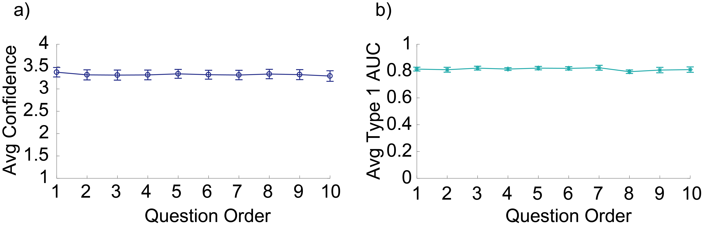

*Figure 13.* Average confidence and AUC, for each question in Experiment 2. Results are averaged across trials and participants. Each question was shown one after the other, in order from 1 to 10, for each image. Three of the questions had present descriptors, and seven had absent descriptors. The order of questions was randomised for each image and participant. a) Average confidence was constant at around 3.40 for all questions. This suggests that participants were fairly sure of their answers, even after being asked 10 separate questions for each image. b) Average AUC was constant at around 0.80 for all questions.

**Conscious information processing: Bits and bits/sec**

On average, participants processed 5.28 bits/sec (*SD* = 0.12) for each of 10 questions, for a total of 52.80 bits/sec. Figure 14 shows the amount of information processed for each question (bits) in Experiment 2, and information processed for each second, extrapolated from participants’ performance at 133ms SOA.

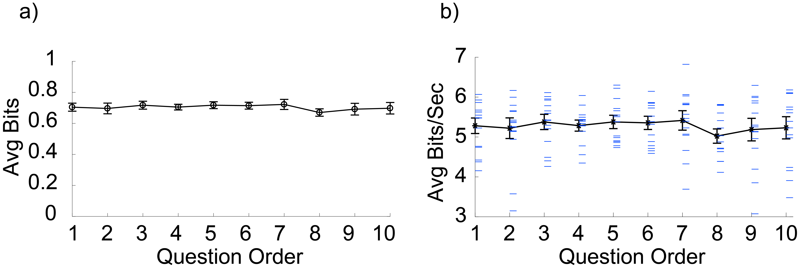

*Figure 14.* Amount of information (in bits) processed for each of 10 questions for an SOA of 133ms, and extrapolated to the amount of information processed per-second. a) Average information for each question (bits), at a constant SOA of 133ms (mean ± standard error of the mean, over subjects). Information remains constant across questions, at an average of 0.70 bits/question. b) Average information for each question, extrapolated to a duration of one second to give bits/sec. The black line represents bits/sec averaged across participants and trials, with error bars reflecting standard error of the mean. The blue lines represent individual participant data. On average, participants’ information processing was constant at around 5 bits/sec across all questions.

**Experiment 3: Testing the Limits of Reporting**

We saw no decrease in objective accuracy for 10 questions in Experiment 2, which suggests no decay of information as a function of number of questions asked. As such, participants ought to be able to perform highly on a large number of questions, when asked about both present and absent aspects of a scene. We doubled the number of questions for Experiment 3 to 20, to test if any decay would occur.

**Methods**

Participants were five volunteers (one male, four female) aged 22-24 (*M* = 22.80, *SD* = 0.84). There were only two changes from Experiment 2. Firstly, we increased the number of questions per-trial from 10 to 20. Within the 20 questions, four present and 16 absent descriptors were displayed. Secondly, we decreased the total number of trials from 180 to 90 to maintain the same total task duration. We used the first 90 images (in order of image ID) from Experiments 1 and 2 as stimuli for Experiment 3. The pool of descriptors used was therefore also limited to descriptors of the 90 images (a total of 776 descriptors). Due to the decrease in total descriptors, each participant may have seen the same absent word for more than one image (e.g. ‘fountain’ as one of the descriptors for image one, and ‘fountain’ again for image 30). However, like in Experiment 2, each participant was shown a different set of absent words for each image, with no overlap between participants.

**Data Analysis**

Data was analysed using the same method as Experiment 2.

**Results**

Average confidence levels and AUC for each question are shown in Figure 15. On average, participants were highly confident (*M* = 3.79, *SD* = 0.04) and accurate (*M* = 0.79, *SD* = 0.03) in their answers, for all questions.

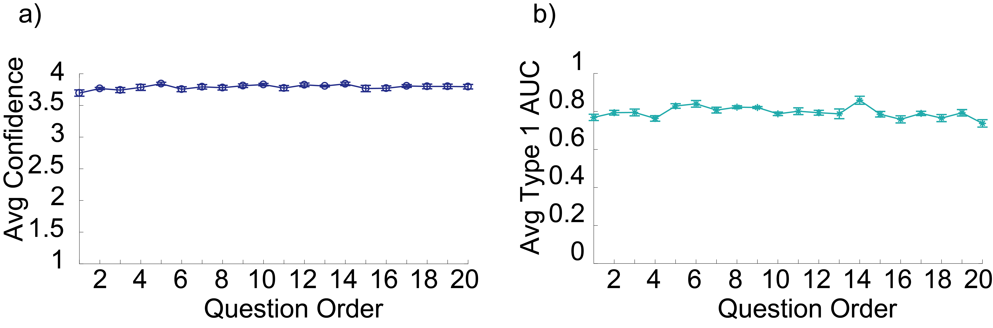

*Figure 15.* Average confidence and AUC, for each question in Experiment 3. Results are averaged across trials and participants. Each question was shown one after the other, in order from 1 to 20, for each image. Four of the questions had present descriptors, and 16 had absent descriptors. The order of questions was randomised for each image and participant. a) Average confidence was constant at an average of 3.79 for all questions. This suggests that participants were fairly sure of their answers, even after being asked 10 separate questions for each image. b) Average AUC was constant at around 0.79 for all questions. This means that participants were highly accurate for their answers, for all questions.

**Conscious information processing**

On average, participants processed 5.01 bits/sec for each of 20 questions, for a total of 100.20 bits/sec. Figure 16 shows the amount of information processed for each question (bits/question) in Experiment 3, as well as information processed for each second, extrapolated from participants’ performance at 133ms SOA.

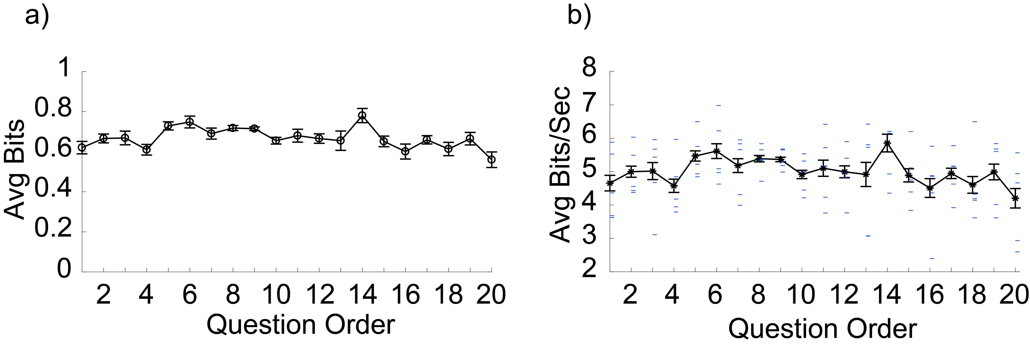

*Figure 16.* Amount of information (in bits) processed for each of 20 questions for an SOA of 133ms, and extrapolated to the amount of information processed per-second. a) Average information for each question (bits), at a constant SOA of 133ms (mean ± standard error of the mean, over subjects). Information remains constant across questions, at around 0.70 bits/question. b) Average information for each question, extrapolated to a duration of one second to give bits/sec. The red line represents maximum bits/sec if participants performed at 100% accuracy (i.e. AUC of 1). The black line represents bits/sec averaged across participants and trials, with error bars reflecting standard error of the mean. The blue lines represent actual participant levels. On average, participants’ information processing was relatively constant across all questions.

**General Results**

Across all three experiments, scores for Accuracy and AUC were within range (0-1), as were Confidence scores (1-4). No missing values or outliers were found for any variables (see Appendix C for descriptive statistics for all experiments).

**Performance Trend Across 1, 0 and 20 Questions at 133ms SOA**

In order to determine how well participants performed when making present/absent judgements, relative to a theoretical near-perfect performance, we used two measures: objective accuracy and participants’ bits/sec *efficiency*. We viewed this trend across all three experimental paradigms, with 1, 10 and 20 questions, at 133ms SOA.

**Objective accuracy and confidence across experiments**

We first calculated objective accuracy and confidence, averaged across participants, trials and questions for all three experiments at 133ms. Figure 17 provides a comparison of average objective accuracy and confidence for all three experiments, at 133ms. Due to a non-normal distribution, we used a Kruskal-Wallis ANOVA (Field, 2013), which revealed no significant difference in objective accuracy per-question among the three experiments, χ2(2,37)=4.81, *p* = .09. This indicates that performance on all three experiments was not significantly different. On average, participants performed at 0.80, 0.81 and 0.79 objective accuracy for experiments 1, 2 and 3, respectively. ­­A Kruskal-Wallis ANOVA was also conducted for confidence, showing there was a significant difference amongst the three experiments, χ2(2,37)=30.87, *p* = <.001. Post-Hoc Multiple-Comparisons revealed that there was no difference between Experiment 1 and Experiment 2, but there was a significant difference between Experiment 1 and 3 (Mean*diff* = -23.30, *p* < .001), and Experiment 2 and 3 (Mean*diff =* -16.70, *p* < .001). Experiment 3 had the highest average confidence ratings among all three experiments.

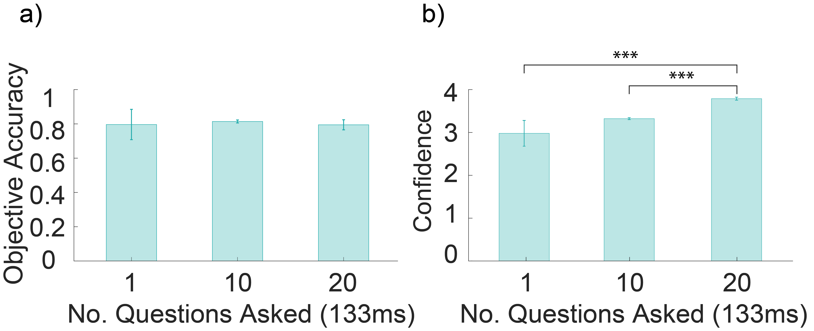

*Figure 17.* a) Objective accuracy, averaged across participants, trials and questions for each experiment (1 question for Experiment 1, 10 questions for Experiment 2 and 20 questions for Experiment 3). b) Confidence, averaged across participants, trails and questions for each experiment. Note: \*\*\**p<*.001.

**Information Processing Per-second**

Next, we compared average bits/sec per question, across experiments. Since AUC was not significantly different, the amount of information processed for each question (which was just a log transformation of AUC) was also not significantly different among all three experiments. On average, we estimated that participants processed 4.98, 5.28 and 5.01 bits/sec for each question in experiments 1, 2 and 3, respectively.

**Bits/sec efficiency**

We defined efficiency as the following:

$$efficiency=\frac{Participants^{'} actual information }{Maximum possible information}$$

Where maximum possible information is the highest measured average objective accuracy in Experiment 1 (AUC of 0.84). We applied Equations 1 and 2 to this maximum value, to calculate maximum possible information. For Experiment 1, maximum information was 5.62 bits/sec. For Experiment 2, where we asked 10 questions, maximum information was 56.22 bits/sec, equivalent to 10 times the information for one question. For Experiment 3, where we asked 20 questions, maximum information was 112.44 bit/sec, equivalent to 20 times the information for one question.

In Experiment 1, participants’ actual information processing was, on average, 4.98 bits/sec for a duration of 133ms. This meant they performed at 88.42% efficiency. In Experiment 2 participants’ information processing was 52.75 bits/sec for a duration of 133ms, meaning they performed at 93.84% efficiency. In Experiment 3, participants’ information processing was 100.16 bits/sec for a duration of 133ms, performing at 89.08% efficiency (Figure 18 shows bits/sec performance and efficiency across experiments).

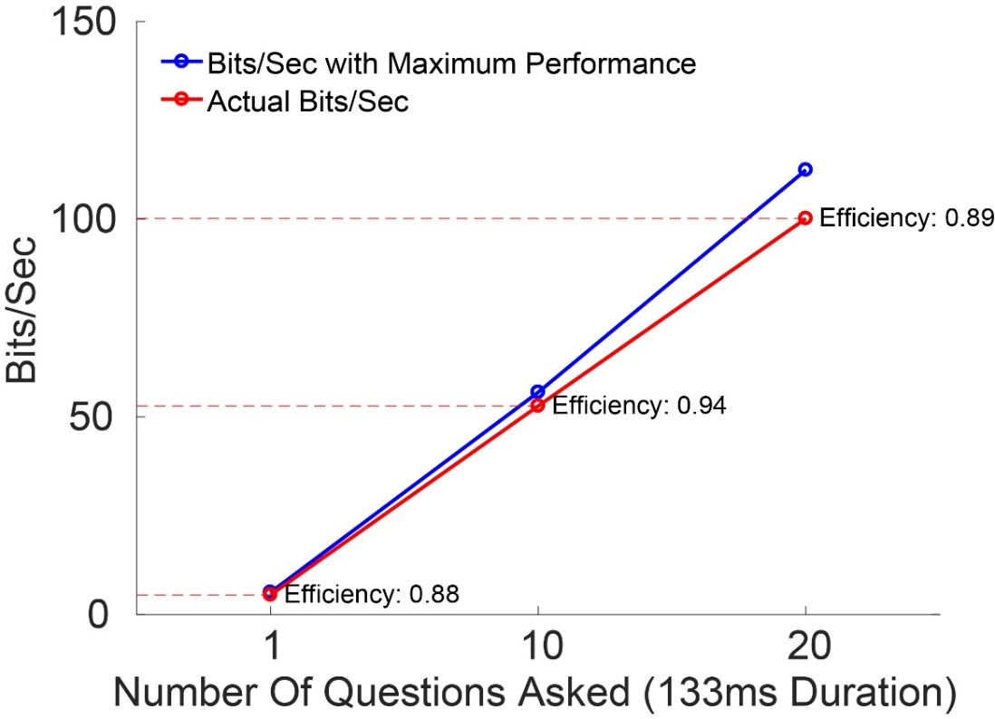

*Figure 18.*A representation of participants’ actual information processing estimate (represented by the red circles) for all three experiments. We compared this estimate with the amount of information participants would process if they performed maximally (represented by the blue bars). Participants’ efficiency is shown next to their actual performance, and represents their actual performance divided by the theoretical maximum performance. Efficiency was constant at around 90% across all three experiments.

**Comparing Present and Absent Judgements**

While participants’ objective accuracy was high across all three experiments, leading to a corresponding high estimate of information processing, we wanted to determine whether this measure might be different for present and absent information. However, since Type-1 AUC cannot be calculated for present and absent descriptors separately (Green & Swets, 1974), we split participants’ raw-accuracy scores into absent or present responses, and compared them for each experiment using a non-parametric Mann Whitney-U (Field, 2013). Raw-accuracy reflects participants’ performance without accounting for confidence or introspection. We used a non-parametric measure because accuracy and confidence were non-normally distributed. Test statistics and p-values for all tests conducted across the three experiments are shown in Table 3.

Table 3

*Mann Whitney-U Statistics comparing Present and Absent responses for Objective Accuracy and Confidence levels, for all three experiments*

|  |  |  |  |  |  |  |
| --- | --- | --- | --- | --- | --- | --- |
|  | | Objective Accuracy | | | Confidence | |
|  | *U* | | *p* | *U* | | *p* |
| Experiment 1 | 2959 | | .07 | -4305 | | **.013** |
| Experiment 2 | 5551 | | **<.001** | 5383.5 | | **<.001** |
| Experiment 3 | 90.5 | | **<.001** | 258.5 | | **<.001** |

Note: bold represents significant p-values at an alpha level of .05. *U* represents the Mann Whitney-U test statistic, and *p* the p-value. We compared accuracy or confidence on present questions with performance on absent questions. Negative values represent present scores being higher than absent, and positive values represent absent scores higher than present.

Significance was unchanged after applying false-discovery-rate corrections for multiple comparisons (Benjamini & Hochberg, 1995). For both Experiments 2 and 3, participants were significantly more accurate and confident when reporting on absent descriptors than present descriptors. However, in Experiment 1, participants were more confident when reporting on present descriptors than absent descriptors. Figure 19 and 20 show the difference in accuracy and confidence, respectively, for experiments 1-3, based on proportion of present descriptor questions for each trial.

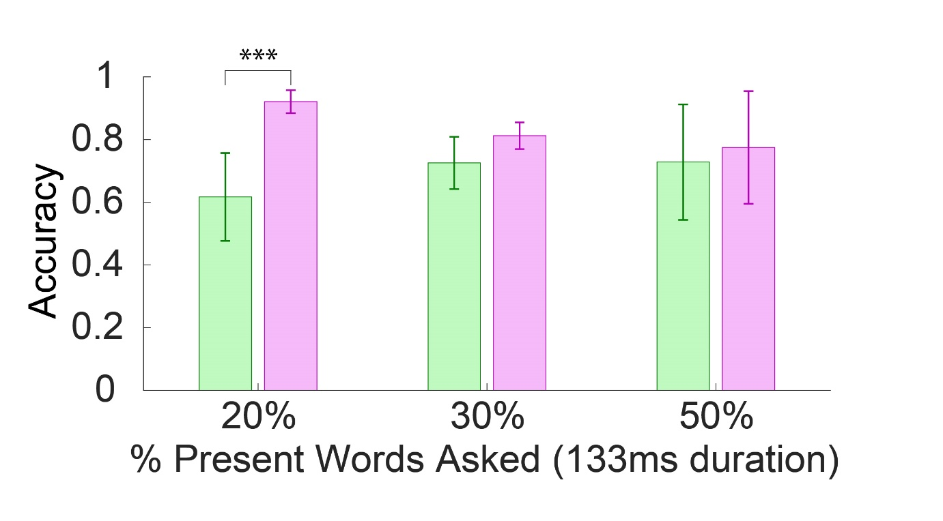

*Figure 19*. Participants’ average raw-accuracy for absent (pink) and present (green) descriptors, based on the percentage of present questions asked in Experiments 3 (20%), 2 (30%) and 1 (50%). Percentage (%) of present words asked refers to what proportion of the total number of questions per trial for each experiment were present. 20% present refers to Experiment 3, where out of the 20 questions, 4 questions were present for each trial, and 16 were absent. 30% refers to Experiment 2, where out of the 10 questions, 3 questions were present for each trial and 7 were absent. 50% refers to Experiment 1, where for each single question there was a 50% chance of it being present and a 50% chance of it being absent. Raw-accuracy for absent descriptors was significantly greater than present descriptors for Experiment 2 and 3, but not significant for Experiment 1. Note: \*\*\**p* < .001.

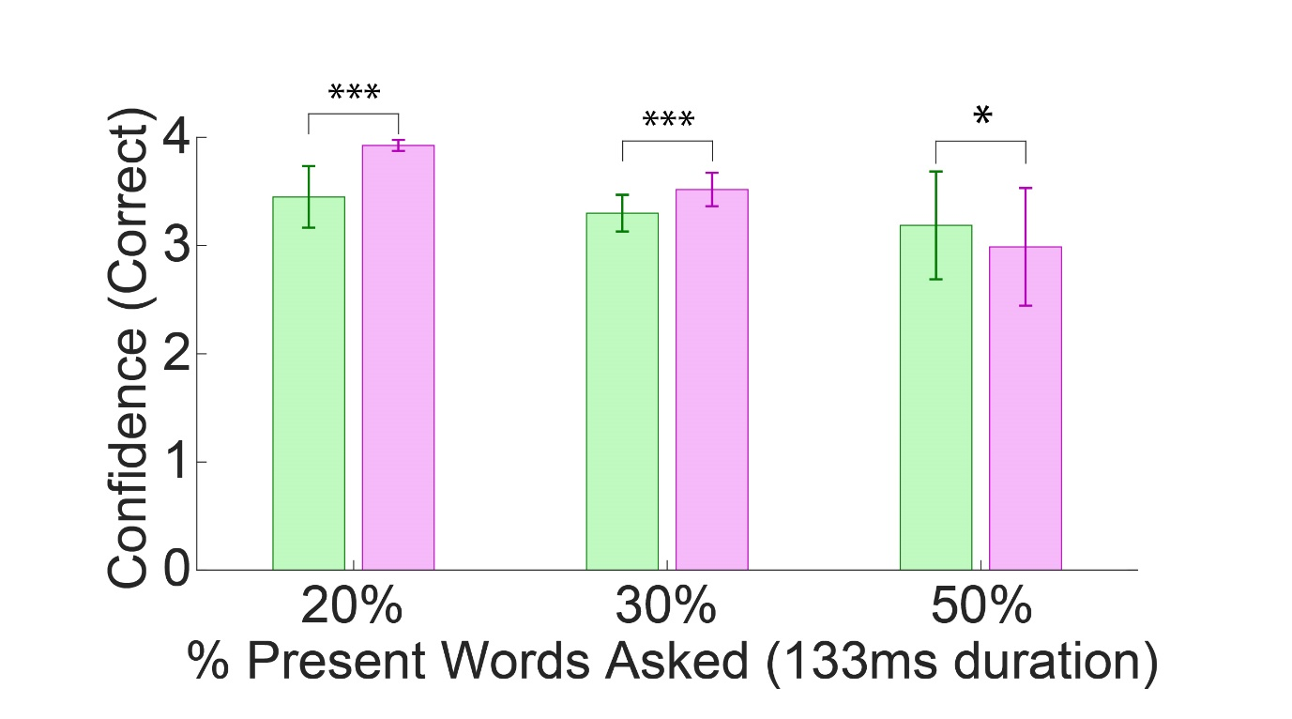

*Figure 20.* Participants’ average confidence for correct responses only, for absent (pink) and present (green) descriptors, based on the percentage of present questions asked in Experiments 3 (20%), 2 (30%) and 1 (50%). Percentage (%) of present words asked refers to what proportion of the total number of questions per trial for each experiment were present. 20% present refers to Experiment 3, 30% refers to Experiment 2 and 50% refers to Experiment 1.Confidence for absent descriptors was greater than present descriptors for all three experiments. Note: \**p* < .05, \*\*\**p* < .001.

**Can people report on both present and absent words for 20 questions, without decay of accuracy?**

**S**ince the proportion of present to absent descriptors decreased from 50:50 in Experiment 1 to 30:70 in Experiment 2 and again to 20:80 in Experiment 3, we wanted to see if participants’ raw-accuracy would change based on the question order in which they were asked. For instance, in Experiment 3 participants were given 16 absent descriptors for each image, and only 4 present descriptors; if the present descriptors were shown in the last few questions (e.g. between questions 10-20), participants may have been less accurate in their responses, as they would need to remember what they saw 20 questions earlier. To test this, we conducted Pearson correlations comparing participants’ raw-accuracy for present descriptors with question order at which the descriptors were asked. There was no significant correlation between both variables for Experiment 2, *r* = .02, *p* = 0.41, or for Experiment 3, *r* = -0.16, *p* = 0.11. We also compared participants’ accuracy for absent descriptors with question order. There was no significant correlation between the two variables for Experiment 2, *r* = 0.19, *p* = 0.82. However, there was a significant, moderate and positive correlation for Experiment 3, *r* = 0.28, *p* < .01. Figure 21 shows scatterplots with correlation lines for Experiment 2 and Experiment 3.

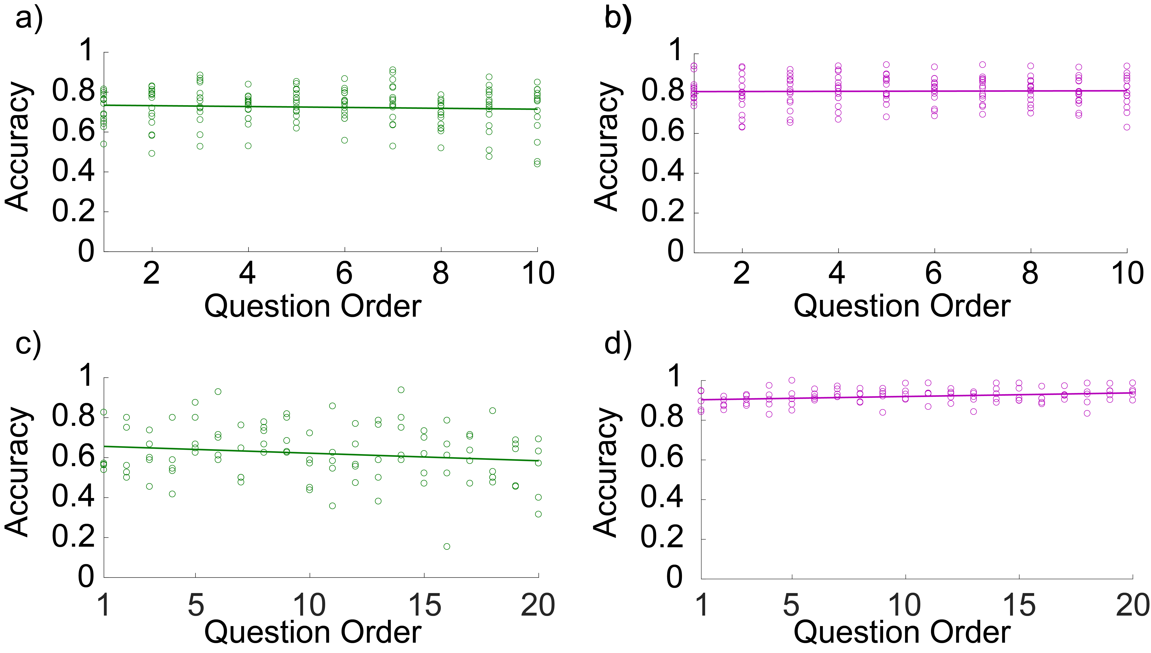

*Figure 21.* Scatterplots for each participants’ (circles) raw-accuracy when reporting on present (green) and absent (pink) descriptors in Experiments 2 and 3. Responses are averaged across trials. Straight coloured lines represent a correlation line-of-best fit. (a) Experiment 2 correlations for present words. There was no significant decay in performance for present descriptors shown in questions that were asked closer to image presentation (i.e. questions 1 – 5) to questions asked later (i.e. questions 5-10). (b) Experiment 2 correlations for absent words. There was no significant decay in performance for absent descriptors in earlier questions than later questions. (c) Experiment 3 correlations for present words. There was no significant decay in performance on present descriptors for questions that were asked closer to image presentation (i.e. questions 1 – 10) to questions asked later (i.e. questions 10-20). (d) Experiment 3 correlations for absent words. There was a significant positive correlation between absent descriptors and question order, meaning that as the number of questions in which absent words were presented increased, participants were more accurate on absent judgements.

**CHAPTER 3: DISCUSSION AND CONCLUSION**

**General Discussion**

The present study aimed to quantify the amount of information people can extract from a brief exposure to a natural scene. This study is the first to our knowledge to consider reports on both present and absent aspects of a scene as constituting information. Furthermore, we aimed to examine changes in participant performance, as a function of scene duration. In order to investigate our aims, we employed a computerised binary-choice task with confidence measures, asking participants to make judgements on present and absent aspects of a real-world scene. Here we discuss our general results in relation to previous measurements of BOC, as well as explanations for and implications of our findings, within context of the study’s strengths and limitations.

**Measuring Conscious Information**

Previous studies which demonstrate high-capacity information processing at short durations fail to quantify the amount of information consciously processed (Bronfman et al., 2014; Lamme, 2003; Sperling, 1960; Potter et al., 2014). To our knowledge, estimates in the literature maximally estimate BOC at 40 bits/sec (Norretranders, 1998; Zimmerman, 1998). We hypothesised finding BOC greater than 40 bits/sec by including absent aspects as constituting information. Our findings showed BOC of 52 bits/sec for 10 questions and 100 bits/sec for 20 questions when images were shown for SOA of 133ms, supporting our hypothesis. This extends conscious information research by quantifying BOC that hints at high-capacity conscious information processing.

**Do absent judgements constitute information?**

An important methodological innovation in our approach was testing whether participants can report on aspects absent from a scene, as well as present. Previous consciousness literature has not considered including absent aspects of a scene in the contents of consciousness. How can one extract information about the scene from something not reported to be part of it? The answer is in the information theory definition of information, which states information is a reduction of uncertainty (Shannon, 1948). In our study, when asked about an absent aspect of a scene, participants were required to make a yes/no judgement – a choice between two alternatives. This process involves a reduction in uncertainty regarding whether or not that aspect is absent from the scene. By correctly stating a descriptor was present in a scene, participants reduced uncertainty about what was present in the scene. The same thing can be said about making an absent judgement: uncertainty about what is in the scene is still reduced by knowing what is not in the scene. By gaining insight into what is *not* in a scene, one can gain more information about the scene itself. Therefore, by definition, absent judgements constitute information in the same way as present judgements do.

**Efficiency**

In the current study, participants’ efficiency rates were highly similar when answering 1, 10 or 20 questions about an image; ranging from 89 – 93%. This indicates a general trend of information processing performance, regardless of the number of questions asked. As such, our estimate of 100 bits/sec was limited only by the number of questions participants were asked. Assuming no decay in performance, extending the number of questions asked might increase this estimate. In order for our paradigm to directly address questions about richness, it would be interesting to extend it to 100 or even 1000 questions, to test if the trend remains. If we see a constant efficiency, this would provide a closer estimate of how much information participants can report on, without being limited by the number of questions they are asked. Furthermore, this would indicate that people can report on hundreds or even thousands of present and absent aspects of a scene, which would match up more closely with our subjective richness.

**Are Some Absent Aspects More Informative Than Others?**

It may be argued that some absent concepts may be more informative than others when making judgements on a scene. For instance, saying a ‘tree’ is absent from a classroom scene may constitute less information than saying it is absent from a garden scene. In the former case, one would not expect a tree in a classroom, compared to a garden scene. Therefore, the former case should reflect ‘more’ information than the latter; we have greater uncertainty of the tree being absent from garden than from the classroom. The role of expectation on absent information processing is unclear at this preliminary stage. We plan to conduct follow-up studies to determine whether different types of absent concepts in different contexts or categories constitute varying amounts of information.

Nonetheless, testing absent aspects of a scene provides important additional insight into participants’ experience, which was not available in previous studies. With enough knowledge of absent aspects of a scene (assuming constant efficiency) it may be possible to construct what a participants’ experience of the scene was like. Furthermore, combining absent and present aspects would provide a more accurate picture of participants’ subjective experience.

**How Well did Participants Perform on the Task?**

**Objective accuracy**

In the current study, participants performed at well above chance levels, averaging around 0.80 AUC across all three experiments. Confidence levels were also high across all three experiments for correct answers. These results demonstrate that participants were highly aware of mistakes or inconsistencies in their answers, and could adjust their confidence properly based on their introspection. Objective accuracy has been shown to measure how well participants can match up their performance with their introspection (Fleming & Lau, 2014; Meuwese et al., 2014).

**Performance does not decay after 20 questions**

Based on previous findings, we would expect participants to only be able to report on 4-5 aspects of a scene (Clarke & Macke, 2014; Franconeri et al., 2007), after which information starts to decay. In our study, participants were asked to report whether they thought 1, 10 or 20 words were present or absent from a scene, across three experiments. We did not see a significant decay in accuracy for present or absent descriptors, after 10 or even 20 questions asked. Our findings may indicate that access consciousness has a higher capacity than previously thought (Clarke & Macke, 2014; Miller, 1956), when including absent and present aspects of a scene. Participants were able to report on both present and absent descriptors at above chance-level accuracy, without significant decay. As such, our estimate of 100 bits/sec taken from these 20 questions is probably not even close to the limit of participants’ performance, and significantly underestimates the actual bandwidth of conscious information processing.

It is possible that if we asked participants 6 or 7 present questions per image, accuracy would decrease. Further research is required to determine information decays across any number of questions, both present and absent. If no decay is seen at 100 or 1000 questions, our estimate of conscious information processing would be much larger, and more closely match our subjective experience of richness.

**Limitations**

Our use of a binary-choice task to calculate BOC in support of richness may be criticised as limiting participants’ responses to pre-determined choices provided by the experimenter (Fei-Fei et al., 2007; Haun et al., 2017). In this case, criticism of binary-choice tasks having only a pre-determined set of solutions is, at least partially addressed by collecting pre-determined words from free-flowing, non-limited descriptions from 5 unique individuals. Furthermore, if participants’ responses were, in fact, limited by a binary-choice task, then any measure of BOC we obtain from the task serves only as a lower-bound for the potential amount that could be extracted from non-binary-choice tasks, which supports richness even further.

Furthermore, our study could be criticised for showing a much higher ratio of absent words to present words in experiments 2 and 3. Participants saw 70% or 80% absent words, and only 30% or 20% present words in each experiment, respectively, compared to Experiment 1, when they were shown 50% absent and 50% present. As such, our measure of participants’ performance may be criticised as an overestimate, without accounting for such potential bias. While number of studies have suggested that response bias affects people’s confidence ratings (e.g. Balson & Azzopardi, 2015), there is contention in the literature whether it influences their accuracy (Peters, Ro & Lau, 2016; Samaha & Postle, 2017). We partially addressed potential concerns associated with bias by randomised the order of the presented words for each image in order to reduce order effects and expectation. Furthermore, comparison of experiment 2 and 3 accuracy and confidence, with Experiment 1, which was free of response bias, revealed no significant difference in objective accuracy. We did, however, find significantly higher confidence ratings for present descriptors than absent descriptors in Experiment 1, but the opposite in experiments 2 and 3. Furthermore, preliminary analysis using *d’* (d-prime) which is a bias-free measure of sensitivity (Stanislaw & Todorov, 1999) supports our measure of objective accuracy (although whether this is truly bias free is also contended; Witt, Taylor, Sugovic & Wixted, 2015). Our findings contribute to the debate in the literature surrounding the effect of response bias on performance in signal-detection paradigms, suggesting that response bias does seem to affect people’s confidence measures, but not their accuracy. A future condition looking at 50% present and 50% absent words in a similar paradigm would clarify any remaining concerns around the impact of bias.

**Significance and Implications**

**Significance**

The current findings highlight a gap in the literature; absent information has never been considered as conscious information. This study was the first to our knowledge to question people on aspects absent from a scene. We designed a novel method based on suggestions by Haun and colleagues (2017) to overcome the limitations of previous paradigms. Previous studies relying upon only present aspects of a scene to estimate the bandwidth of consciousness show a maximum of 40 bit/sec (Norretranders, 1998; Zimmerman, 1986), and are limited by the number of items available to participants’ recall (Haun et al., 2017). While subjects do not normally report absent aspects in previous tasks, it is not because they are not consciously aware of them, but simply because they are not asked about them (Haun et al., 2017). The current findings demonstrate that our subjective experience of the world as highly rich may be supported by experimental evidence, when asking participants to report on aspects of a scene other than just what was present. It would be difficult to measure similar estimates of information processing when asking only about present items, as participants’ responses would be limited by working memory capacities (Clarke & Mack, 2015). Our novel method allows questioning participants about aspects of a scene they are consciously aware of, without limiting their reports to only those items they can recall as present. Since richness predicts a highly detailed experience, if a participant’s reports hint at such an experience we can have greater confidence in the methodology used to collect their reports (Haun et al., 2017).

Using this method, we found that participants could consciously process 100 bits of information per-second. While this estimate is still not reflective of our subjective experience of richness, it serves as a conservative lower-bound for the amount of information which can be consciously processed. This is because we only applied one of the number of suggestions offered by Haun et al. (2017) for overcoming limitations of previous experiments, and only asked a limited number of questions. If we also asked participants about spatial orientation, topographic relations (Tononi et al., 2016) or colour diversity (Bronfman et al., 2014) of aspects of a scene, this amount could increase exponentially. In a Sperling task alone, we could report there are many white symbols, they are arranged in three rows and four columns, in a rectangular array, within a rectangular display, over a grey background, being composed of a multitude of distinguishable locations, each with its specific neighbours, and so on (Tononi et al., 2016). These concepts form our experience of the array itself, and are typically taken for granted by experimenters rather than included in estimates of conscious information. Our results support frameworks such as that proposed by Tononi and colleagues (2016), in redefining what constitutes conscious information. Consequently, our findings may provide further evidence for the view of consciousness as highly rich, rather than illusory and sparse, in the ongoing debate surrounding the informational contents of consciousness in the literature. We encourage modification of paradigms attempting to quantify consciousness, to account for what participants might be seeing but not reporting on (Gregory, 1987).

**Support for phenomenal consciousness**

Our results support previous findings by Potter (1976) and Wu et al., (2014), amongst many other studies, which claim humans can consciously process a large amount of information from scenes with presentation durations as low as 100ms. The current results may lend support to a number of hypothesised models of conscious processing which suggest at extremely quick image durations, an initial wave of neural activity through the ventral stream is sufficient to allow identification of a complex visual stimulus in a single forward pass (Lamme & Roeflsema, 2000; Potter et al., 2014; Serre, Oliva, & Poggio, 2007). At these durations, there is not enough time for the top-down attention to act on the information entering consciousness (Lamme, 2003). Additionally, since the images in our experiments 2 and 3 were only shown for 133ms, followed by masking, participants’ reports must have been reflections of their conscious processing of the scene, rather than reliance on an afterimage (Dick, 1974). As such, our findings support Lamme’s (2003) assertion that conscious experience of a stimulus or visual scene is entirely determined during early build-up of sensory representations, within 100-150ms following stimulus presentation. This view advocates Block’s (2014) phenomenal consciousness, and consequently, richness.

**Implications**

Our results imply that, if the focus of what constitutes conscious information is extended to aspects of a visual scene other than present objects or items, measures of conscious information processing may match up with our rich experience. We found participants significantly more accurate in their ratings when absent than present judgements. We interpreted these findings to imply absent judgements are as, or even more, informative about what comprises a scene than present judgements, based on information theory (Shannon, 1948). This may be conceptually likened to differential diagnosis in medicine or psychology, where diseases are diagnosed by ruling out alternative diseases one by one, until the most likely disease is left (First, 2013). While this may be highly time-consuming, perhaps some level of our consciousness works in a similar manner. We might have a limited capacity for perceiving items/objects present in a scene, but a large capacity for negative-perception of aspects absent from the same scene. Depending on the context, knowing something is *not* in a scene may help form a conscious representation of the scene. For example, knowing there is no lion in a forest might help a person judge it as safe for picking berries. Furthermore, while participants may only remember 4 letters from a Sperling (1960) task, the amount of information they can gain from the scene is actually much higher than this, based on what they did *not* see in that scene. Participants *know* the third letter of the second row was not a number, or a smiley-face, or a lion; this has also been demonstrated in previous studies (e.g. De Gardelle, et al., 2009). Perhaps our understanding of a real-world scene relies on absent concepts as much as, if not more so, than present aspects of the scene. This could imply that absent concepts form half of our conscious experience, and that previous research has completely overlooked half of information used to form this experience. Our results also imply that there may be no limit to the amount of absent information we can consciously report on. Whether this can also be said for present information is to be seen. Follow up experiments would shed light on how present and absent concepts interact to form our experience.

Our results could also have a number of real-world applications. Advertisers may, for instance, utilise these findings to portray much more information than previously thought possible into people’s conscious experience, when viewing an ad on TV or a billboard. Artificial intelligence (AI) creators might focus on negative-concepts when programming robots to ‘perceive’ the world around them; instead of focusing only on things which the AI knows is present, they may try to teach it to draw upon things absent from the scene to shape its performance. Most importantly, by including reports on absent, amongst other aspects of a scene to explain the contents of consciousness, our understanding of how humans experience the world around them may deepen.

**Future Directions/Research**

Analysis of the current data separating descriptors into groups of verbs, nouns, adjectives, etc., would shed light on the brains’ conscious categorisation process. For example, participants anecdotally reported finding it much easier to make a present/absent judgement for nouns than verbs, which were in turn both easier than adjectives or function words. Previous research suggests children learn nouns more rapidly than verbs, implying the former may be more important for structuring our understanding of the world (Gentner, 1981). Furthermore, neural evidence has shown that nouns activate posterior areas of the brain related to sensory and associative processing, while verbs activate more anterior motor areas (Cangelosi & Parisi, 2004), suggesting the former may have provide more semantic information than the latter. Follow-up analysis to determine peoples’ information processing capabilities for each type of word (noun, verb, etc.) would clarify how our brain categorises and processes information, and what types of information are more available to us consciously.

Furthermore, conducting an experiment using present and absent judgements in the original Sperling (1960) task is important. While paradigms such as the Sperling task fail to account for the full range of richness across natural everyday scenes, it is an often-used paradigm in the consciousness debate. Therefore, a comparison of our current findings with results from previous experiments within a limited Sperling array is important, to increase generalisability of our results, and demonstrate richness even in such a limited context (Tononi et al., 2016).

**Conclusion**

Results from our study suggest conscious processing of information is much greater than previous estimates in the literature. Specifically, we quantified the bandwidth of consciousness as at least 100 bits/sec. Our findings serve as a lower-bound estimate of the amount of information consciously processed by humans, which will likely increase in future studies. This research contributes to the growing body of literature which supports a rich and highly detailed nature of visual experience and consciousness.

Author Notes

I would like to acknowledge and thank Naotsugu Tsuchiya and Jeroen van Boxtel for their support, expertise and guidance as supervisors. I also thank members of the Tsuchiya Lab (t-lab) and Monash Neuroscience of Consciousness (MONOC), particularly Julian Matthews, for their ongoing support and feedback during the year. I would like to thank Shinji Nishimoto and Satoshi Nishida from the National Institute of Information and Communications Technology in Tokyo, for their collaboration and provision of the stimuli for the current project.

I am also grateful for the friendship of my fellow honours students at Monash Biomedical Imagery (MBI). This year would not have been possible without them. To my family – Leah, Yohanan, Ella and Maia – thank you for putting up with me this year, for your time reading and listening to my endless drafts, and for your endless care and support. I would further like to acknowledge the funding awarded by the Monash University School of Psychological Sciences, and thank them for their support of this project and other work conducted by the Tsuchiya laboratory.

**CHAPTER 4: REFERENCES**

Alvarez, G. A. (2011). Representing multiple objects as an ensemble enhances visual cognition. *Trends in Cognitive Sciences*, *15*(3), 122-131.

Alonso, J. M., & Chen, Y. (2008). Receptive field, *Scholarpedia, 4*(1), 5393.

Anstis S. (1998). Picturing peripheral acuity. *Perception, 27*, 817–826.

Aru, J., & Bachman, T. (2013). Phenomenal awareness can emerge without attention. *Frontiers in Human Neuroscience, 7*, 891. doi: 10.3389/fnhum.2013.00891.

Attneave, F. (1955). Symmetry, information, and memory for patterns. *The American Journal of Psychology, 68*(2), 209-22.

Awh, E., Vogel, E. K. & Oh, S. H. (2006). Interactions between attention and working memory. *Neuroscience, 139*, 201-208. doi: 10.1016/j.neuroscience.2005.08.023.

Baars, B. (1989). *A Cognitive Theory of Consciousness*. Cambridge (England): Cambridge University Press.

Brainard, D. H. (1997). The Psychophysics Toolbox. *Spatial Vision,* 10, 433-436.

Baur, B. (2009). Does Stevens's power law for brightness extend to perceptual brightness averaging? *Psychol. Rec., 59,* 171–186

Becker, M. W., Pashler, H., & Anstis, S. M. (2000). The role of iconic memory in change-detection tasks. *Perception, 29*(3), 273-286.

Benish, W. A. (2003). Mutual information as an index of diagnostic test performance. *Methods Inf Med, 42*(3), 260-264.

Benjamini, Y., & Hochberg, Y. (1995). Controlling the false discovery rate: A practical and powerful approach to multiple testing. *Journal of the Royal Statistical Society. Series B (Methodological), 57*(1), 289-300.

# Biederman, I., Rabinowitz, J. C., Glass, A. L., & Stacy, E. W., Jr. (1974). On the information extracted from a glance at a scene. *Journal of Experimental Psychology, 103*, 597–600.

Block, N. (1995). On a confusion about a function of consciousness [Target article and commentaries]. *Behavioral & Brain Sciences, 18*, 227–287.

Block, N. (2007). Consciousness, accessibility, and the mesh between psychology and neuroscience [Target article and commentaries]. *Behavioral & Brain Sciences, 30*, 481–548.

Block, N. (2011). Perceptual consciousness overflows cognitive access. *Trends in Cognitive Sciences, 15,* 567–575.

Block, N. (2014). Rich conscious perception outside focal attention. *Trends in Cognitive Sciences*, *18*, 445–447.

Breitmeyer, B. G. (2015). *The visual (un)conscious and its (dis)contents: A microtemporal approach.* New York: Oxford University Press.

Bronfman, Z., Brezis, N., Jacobson, H., & Usher, M. (2014). We see more than we can report: “Cost Free” color phenomenality outside focal attention. *Psychological Science, 25*(7)*,* 1394-1403. doi: 10.1177/0956797614532656.

Cangelosi, A., & Parisi, D. (2004). The processing of verbs and nouns in neural networks: Insights from synthetic brain imaging. *Brain and Language, 89*(2), 401-408.

Centor, R. M. (1991). Signal detectability: The use of ROC curves and their analyses. *Med Decis Making, 11,* 102-106.

Clarke, J., & Mack, A. (2014). Iconic memory for the gist of natural scenes. *Consciousness and Cognition, 30,* 256-65.

Cohen, M.A. & Dennett, D.C. (2011). Consciousness cannot be separated from function. *Trends Cogn. Sci. 15*, 358–364.

Cohen, M. A., Dennett, D. C., & Kanwisher, N. (2016). What is the bandwidth of perceptual experience? *Trends in Cognitive Sciences*, *20*(5), 324-35.

Coltheart, M. (1980). Iconic memory and visible persistence. *Perception and Psychophysics, 27,* 183–228.

Dakin, S. C. & Watt, R. J. (1997). The computation of orientation statistics from visual texture. *Vision Res., 37*(22). 3181-3192.

De Gardelle, V., Sackur, J., & Kouider, S. (2009). Perceptual illusions in brief visual presentations. *Conscious Cogn,18*,569-77.

Dehaene, S. (2014) *Consciousness and the Brain.* New York, NY: Viking Press.

Dehaene, S., Changeux, J. P., Naccache, L., Sackur, J., & Sergent, C. (2006). Conscious, preconscious, and subliminal processing: A testable taxonomy. *Trends in Cognitive Sciences, 10,* 204–211.

Dennett, D.C. (1991). *Consciousness Explained*. Boston, MA: Little Brown and Co.

Dick, A. O. (1974). Iconic memory and its relation to perceptual processing and other memory mechanisms. *Perception and Psychophysics, 16*, 575-96.

Egan, J.P. (1975). *Signal detection theory and ROC analysis, Series in Cognition and Perception*. Academic Press, New York.

Fei-Fei L., Iyer, A., Koch, C., & Perona, P. (2007). What do we perceive in a glance of a real-world scene? *Journal of Vision*, *7*(10), 1-29.

Field, A.P. (2013). *Discovering statistics using IBM SPSS Statistics* (4th ed.). London: Sage.

First, M. B. (2013). *DSM-5 handbook of differential diagnosis*. American Psychiatric Pub.

Fleming, S. M., Dolan, R. J., & Frith, C. D. (2012). Metacogntion: Computation, biology and function. *Philosophical Transactions of the Royal Society B, 367*, 1280-6.

Fougnie, D. (2008). *The Relationship between Attention and Working Memory*. In: Johansen, N.B., Ed., New Research on Short-Term Memory, Nova Science Publishers, Hauppage, 1-45.

Franconeri, S. L., Alvarez, G. A., & Enns, J. T. (2007). How many locations can be selected at once? *Journal of Experimental Psychology: Human Perception and Performance, 33*(5), 1003.

Garner, W. R., Hake, H. W. (1951). The amount of information in absolute judgments. *Psychological Review, 58*(6), 446-59.

Gentner, D. (1981). Some interesting differences between verbs and nouns. *Cognition and Brain Theory, 4*(2), 161-178.

Gescheider, G. (1997). *Psychophysics: the fundamentals* (3rd ed.). Mahwah, NJ: Lawrence Erlbaum Associates.

Gilner, L., & Morales, F. (2005). *Academic Resources.* Sequence Publishing. Retrieved August 24, 2017, from http://www.sequencepublishing.com/1/academic.html.

Google Translate. (2017). Available at: https://translate.google.com.au/ [Accessed 14 May 2017].

Green, D. M., & Swets, J. A. (1974). *Signal detection theory and psychophysics*. New York: Wiley

Greene, M. R., & Oliva, A. (2009). Recognition of natural scenes from global properties: Seeing the forest without representing the trees. *Cognitive psychology, 58*(2), 137-176.

Gregory, R. (1987). *The Oxford Companion to the Mind*. London (England): Oxford University Press.

Gray, J. (2002). *Straw Dogs: Thoughts on Humans and Other Animals*. London: Granta.

Haber, R. N. (1971). *Where are the visions in visual perception?* In S. Segal (Ed.), Imagery. New York, NY: Academic Press.

Haber, R. N., & Hershenson, M. (1973). *The psychology of visual perception*. New York, NY: Holt, Rinehart & Winston.

Haun A. M., Tononi, G., Koch, C., & Tsuchiya, N. (2017). Are we underestimating the richness of visual experience? *Neuroscience of Consciousness,* 1-4.

Hick, W. E. (1952). On the rate of gain of information. *The Quarterly Journal of Experimental Psychology, 4,* 11-26.

Horrey, W. J., & Wickens, C. D. (2006). Examining the impact of cell phone conversations on driving using meta-analytic techniques. *Human factors, 48*(1), 196-205.

Kaplan, S. (1992). *Environmental preference in a knowledge seeking knowledge using organism*. New York: Oxford University Press.

Kaunitz, L. N., Rowe, E. G., Tsuchiya, N. (2016). Large capacity of conscious access for incidental memories in natural scenes. *Psychol Sci, 27*, 1266-77.

Keogh, R., & Pearson, J. (2011). Mental imagery and visual working memory. *PLoS ONE, 6, e29221*. doi:10.1371/journal.pone.0029221.

Keysers, C., Xiao, D. K., Földiák, P. & Perrett, D. I. (2005). Out of sight but not out of mind: The neurophysiology of iconic memory in the superior temporal sulcus. *Cognitive Neuropsychology, 22*(3-4), 316-332. doi:10.1080/02643290442000103.

Kimchi, R. (1992). Primacy of wholistic processing and global/local paradigm: A critical review. *Psychological Bulletin, 112*(1), 24-38.

Klemmer, E. T., Frick, F. C. (1953). Assimilation of information from dot and matrix patterns. *Journal of Experimental Psychology, 45*(1), 15-19.

Klein, S. (2015). Metacognition: Using confidence ratings for Type 2 and Type 1 ROC curves [Lecture Abstract]. Retrieved from http://docs.lib.purdue.edu/cgi/viewcontent.cgi?article=1031&context=modvis

Kleiner, M., Brainard, D., & Pelli, D. (2007). What’s new in Psychtoolbox-3? *Perception*, *36*, ECVP Abstract Supplement.

Koch, C., & Tsuchiya, N. (2007). Attention and consciousness: Two distinct brain processes. *Trends in Cognitive Sciences, 11*, 16–22.

Kouider, S., de Gardelle, V., Sackur, J., & Dupoux, E. (2010). How rich is consciousness? The partial awareness hypothesis. *Trends in Cognitive Sciences, 14*, 301–307.

Kress, J. E. (1993). *The ESL teacher's book of lists* (3rd ed.). San Francisco, CA: Jossey-Bass, 3-4.

KUTOOLS. (2017). *KUTOOLS (Version 16).* Haikou, Hainan, China. Retrieved from https://www.extendoffice.com/product/kutools-for-excel.html.

Lamme, V. A. F., & Roelfsema, P. R. (2000). The distinct modes of vision offered by feedforward and recurrent processing. *Trends in Neurosciences, 23*(11), 571-579. doi:10.1016/S0166-2236(00)01657-X.

Lamme, V. A. (2003). Why visual attention and awareness are different. *Trends in cognitive sciences, 7*(1), 12-18.

Lamme, V. A. (2010). How neuroscience will change our view on consciousness. Cognitive Neuroscience, 1(3), 204-220.

Landman, R., Spekreijse, H., & Lamme, V. A. (2003). Large capacity storage of integrated objects before change blindness. Vision research, 43(2), 149-164.

Lau, H., & Rosenthal, D. (2011). Empirical support for higher order theories of conscious awareness. *Trends in Cognitive Sciences, 15*, 365–373.

Levine, G. & Parkinson, S. (1994). *Exp*e*rimental Methods in Psychology.* Hillsdale, NJ: Erlbaum.

Luck, S. J., & Vogel, E. K. (1997). The capacity of visual working memory for features and conjunctions. Nature, 390, 279-281. doi:10.1038/36846.

Macmillan, N. A., & Creelman, C. D. (2005). *Detection Theory: A User's Guide* (2nd ed.). Mahwah, NJ: Lawrence Erlbaum Associates.

Manning, C. D., Raghavan, P., & Schütze, H. (2008). *The term vocabulary and postings lists.* In Introduction to Information Retrieval (p.32-36). Cambridge (England): Cambridge University Press.

Matthews, J., Schroder, P., Kaunitz, L., van Boxtel, J. & Tsuchiya, N. (2017, August 22). Conscious access in the near absence of attention: Critical extensions on the dual-task paradigm. Retrieved from psyarxiv.com/ef45x.

Meuwese, J. D. I., van Loon, A. M., Lamme, V. A. F., & Fahrenfort, J. J. (2014). The subjective experience of object recognition: Comparing metacognition for object detection and object categorization. *Atten Percept Psychophys, 76,* 1057-1068. doi:10.3758/s13414-014-0643-1.

Miller, G. A. (1956). The magical number seven, plus or minus two: Some limits on our capacity for processing information. Psychological Review, 101(2), 343-352.

Miller, E. K., & Buschman, T. J. (2015). Working memory capacity: Limits on the bandwidth of cognition. *Daedalus, 144*(1), 112-122.

Neisser, U. (1967.) *Cognitive Psychology*. New York, NY: Appleton-Century-Crofts.

Nishimoto, S. (2015). CiNet VideoBlocks movie library. Unpublished dataset.

Norretanders, T. (1991). *Mærk verden.* Copehagen, Denmark: Glydendal.

Pelli, D. G., & Tillman, K. A. (2008). The uncrowded window of object recognition. *Nature Neuroscience, 11*(10), 1129-1135. doi:10.1038/nn.2187.

Peters, M. A. K., Ro, T., & Lau, H. (2016). Who’s afraid of response bias? *Neuroscience of Consciousness, 2016*(1), niw001.

Phillips, I. B. (2011). Perception and iconic memory: What Sperling doesn't show. *Mind & Language, 26*(4), 381-411.

Pierce, J. R. (1980). *Introduction to Information Theory* - *Symbols, Signals and Noise* (2nd Ed.). Mineola, NY: Dover Publications.

Pinto, Y., Vandenbroucke, A.R., Otten, M., Sligte, I.G., Seth, A.K., Lamme, V.A.F. (2017). Conscious visual memory with minimal attention. *Journal of Experimental Psychology: General, 146*(2), 214-226.

Potter, M. C. (1976). Short-term conceptual memory for pictures. *Journal of Experimental Psychology: Human Learning & Memory, 2,* 509–522.

Potter, M. C., Wyble, B., Hagmann, C. E., & McCourt, E. S. (2014). Detecting meaning in RSVP at 13 ms per picture*. Attention, Perception, & Psychophysics, 76*(2), 270-279.

Quastler, H. (1955). *Information Theory in Psychology*. Glencoe, IL: The Free Press.

Rensink, R. A. (2002). Change detection. *Annu Rev Psychol, 53,* 245–277.

Rensink, R. A. (2014). Limits to the usability of iconic memory. *Front. Psychol., 5*, 971. doi: 10.3389/fpsyg.2014.00971

Rosenholtz, R. (2011). What your visual system sees where you are not looking. *Proceedings of SPIE (Human Vision and Electronic Imaging XVI),7865,* 786510. doi:10.1117/12.876659

Rousselet, G. A., Mace, M. J. M., & Fabre-Thorpe, M. (2004) Comparing animal and face processing in the context of natural scenes using a fast categorization task. *Neurocomputing, 58-60*, 783-791.

Shannon, C. E. (1948). A mathematical theory of communication. *Bell System Technical Journal, 27,* 379-423.

Shevrin, H. (1996). *Conscious and unconscious processes: Psychodynamic, cognitive, and neurophysiological convergences.* New York, NY: Guilford Press.

Sligte, I. G., Scholte, H. S., & Lamme, V. A. (2008). Are there multiple visual short-term memory stores? *PLoS One, 3*(2), e1699. doi:10.1371/journal.pone.0001699.

Smythies, J. (1996). A note on the concept of the visual field in neurology, psychology, and visual neuroscience. *Perception, 25*(3), 369–371.

Sperling, G. (1960). The information available in brief visual presentations. *Psychological Monographs: General and Applied,* *74*(11), 1–129.

Stanislaw, H., Todorov, N. (1999). Calculation of signal detection theory measures. *Behavior Research Methods, Instruments, & Computers, 31*(1), 137-49.

Sweeny, T.D. et al., (2013). Perceiving group behavior: Sensitive ensemble coding mechanisms for biological motion of human crowds. *J. Exp. Psychol. Hum. Percept. Perf., 39*, 329–337

Swets, J.A., Dawes, R.M., & Monahan, J. (2000). Better decisions through science. *Scientific American, 283*, 82–87

Tononi, G., Boly, M., Massimini, M., & Koch, C. (2016). Integrated information theory: from consciousness to its physical substrate. *Nat Rev Neurosci, 17*(7), 450-61.

Torralbo, A., Walther, D. B., Chai, B., Caddigan, E., Fei-Fei, L., & Beck, D. M. (2013). Good exemplars of natural scene categories elicit clearer patterns than bad exemplars but not greater BOLD activity. *PloS one, 8*(3), e58594.

Tye, M. (2006). Content, richness, and fineness of grain. In T. S. Gendler and J. Hawthorne (eds), *Perceptual Experience.* Oxford: Oxford University Press.

Tyler, C. W. (2015). Peripheral color demo*. I-Perception, 6*(6)*,* 1-5.

van Boxtel, J. J. A., Tsuchiya, N., & Koch, C. (2010). Consciousness and attention: On sufficiency and necessity. *Frontiers in Psychology, 1*, 217. Front Psychol. 2010; 1: 217. doi:10.3389/fpsyg.201.00217.

Vandenbroucke, A. R., Sligte, I. G., Barrett, A. B., Seth, A. K., Fahrenfort, J. J., & Lamme, V. A. (2014). Accurate metacognition for visual sensory memory representations. *Psychological Science, 25*, 861–873.

Vanrullen, R., & Thorpe, S. J. (2001). The time course of visual processing: From early perception to decision-making. *Journal of cognitive neuroscience, 13*(4), 454-461.

Watamaniuk, S. N. J., & Duchon, A. (1992). The human visual-system averages speed information. *Vis. Res., 32*, 931–941

Whitmarsh, S., Oostenveld, R., Almeida, R., & Lundqvist, D. (2017). Metacognition of attention during tactile discrimination. *NeuroImage, 147*, 121-129. doi:10.1016/j.neuroimage.2016.11.070.

Witt, J. K., Taylor, J. E. T., Sugovic, M., & Wixted, J. T. (2015). Signal detection measures cannot distinguish perceptual biases from response biases. *Perception, 44*, 289-300.

Zeki, S. (2003). The disunity of consciousness. *Trends in Cognitive Sciences,* *7*(5), 214-218, doi10.1016/S1364-6613(03)00081-0.

Zimmerman, M. (1986). Neurophysiology of sensory systems. In *Fundamentals of Sensory Physiology* (3rd ed. p. 68-116). Berlin, Germany: Springer.

1. * Glossary
2.
3. * Glossary
4.
5. * Glossary
6.
7. * Glossary
8.
9.
10.
11. * Glossary
12. * Glossary
13.
14. See ‘Using Objective Accuracy to define Bits-Per-Second’ in Chapter 2 for a step-by-step calculation of bits-per-second.
15. * Glossary
16. * Glossary
17. * Glossary
18. * Glossary
19.
20. * Glossary
21.
22. For general discussion, see Chapter 3.